
Mathieu Guastella
Senior Program & Project Manager
Digital Transformation & Program Delivery

  Belgian • Italian  Married • 2 children  Based in 1380 Lasne, Belgium | mg@nanobe.be  +32 495 10 10 11  mat.be/linkedin

Senior Project & Program Manager specializing in critical transformations and the delivery of complex initiatives, with over 26 years of experience in demanding environments (public sector, telecom, finance, industry).
I support organizations in leading and delivering strategic projects and programs, from targeted initiatives to large-scale transformation journeys. I operate in a pragmatic, hands-on manner, with a constant focus on delivery, risk control, and tangible outcomes.
Used to high-stakes environments, I also intervene in programs requiring structuring, stabilization, or recovery, combining governance, operational execution, and change management.
🔑 Key Areas of Expertise

- Large-scale digital transformation (public sector & complex organizations)
Public Service of Wallonia (SPW) • City of Brussels • Proximus • European Commission • Council of Bars and Law Societies of Europe (CCBE)
→ Structuring and leading IT programs (governance, modernization, security)
- Digital Workplace & collaborative environments
Proximus • City of Brussels • Public Service of Wallonia (SPW)
→ Large-scale deployment of collaborative solutions (Microsoft 365, Teams, IoT), standardization, user adoption, and change management
- Business systems, ERP / CRM & Data (SAP, Salesforce, data platforms)
Barco • Christian Mutuality • Banqup • Pirelli
→ Evolution and integration of business systems, omnichannel platforms, and data ecosystems
- Critical programs & complex environments (telecom, public sector, industry)
Telenet • Proximus • Orange • BICS
→ Multi-vendor program leadership, delivery control, and coordination of critical ecosystems
- Cybersecurity & IT risk management
Multi-sector (public, telecom, SMEs, institutions)
→ Security by design, regulatory compliance (NIS2, ISO 27001, GDPR), risk management, and protection of critical environments
- Program governance, structuring & recovery
Multi-sector (public, telecom, industry, fintech)
→ Governance setup, turnaround of complex programs, and stabilization of delivery trajectories
🏆 Key Achievements

- Led strategic programs (up to ~€5–10M, teams of ~50–180 FTE)
- Recovery and stabilization of complex programs (Digital Workplace, CRM, 5G Core)
- Large-scale deployments (e.g. 900+ meeting rooms, 35k+ interactions/year)
- Governance of international multi-vendor ecosystems (Microsoft, AWS, SAP, Google, Nokia…)
- Delivery in complex multi-sector environments (public sector, telecom, industry)

🛠 Skills

🛠 Expertise & Capabilities
Program management in complex multi-vendor environments • IT governance & PMO • C-level stakeholder management • Large-scale change management • Risk management & cybersecurity (NIS2, ISO 27001, GDPR)

🧩 Approaches & Methodologies
Hybrid delivery approaches adapted to complex environments: Agile, Waterfall, PRINCE2 • Change management frameworks (ADKAR)

🛠 Tools & environments
Jira • Confluence • Planview • Microsoft Project • Azure • Microsoft 365 • SAP • Salesforce

💼 Experience

Public Service of Wallonia (SPW) • Regional government
Cross-functional Project Manager ✦ Recommendation letter page 8

Led the definition and deployment of an institutional standard for meeting and videoconferencing rooms as part of a multi-site relocation program (5 buildings, ~86,000 m²), integrating public procurement constraints, cybersecurity requirements, and complex cross-functional coordination.

- Standardized collaboration environments (videoconferencing, meeting rooms, AV equipment, connectivity, networks & Wi-Fi) at institutional scale
- Translated business needs into scalable and industrialized technical architectures
- Orchestrated deployment across 5 buildings within a major organizational transformation context
- Coordinated cross-functional stakeholders: IT, infrastructure, real estate, audiovisual, electrical (low current), and vendors
- Structured and authored technical specifications within complex public procurement frameworks
- Integrated cybersecurity requirements into architecture and equipment choices
- Established project governance, monitored progress, and secured delivery through go-live

Public Sector • Digital Workplace • IT Governance • Smart Buildings • Videoconferencing • Public Procurement • IT Infrastructure • Security

Proximus • Leading Belgian telecom operator
Program Manager — Digital Workplace, IT & Telecom ✦ Recommendation letter page 12

Took over and secured a strategic Digital Workplace and collaboration program in a critical telecom environment, addressing major challenges in scalability, security, and user adoption.

- Led the Digital & Collaborative Workplace program covering collaboration, security, infrastructure, and usage transformation
- Defined and implemented cybersecurity strategy for end-user and collaborative environments
- Deployed Microsoft 365 at scale (Teams, Office 365, Windows 10, SharePoint, Stream)
- Migrated communication environments (Cisco → Skype for Business) and transformed collaboration practices
- Standardized and deployed videoconferencing solutions across 900+ rooms
- Implemented data classification and encryption (Azure AD, AIP, RMS)
- Developed Smart Office initiatives (IoT, sensors, cameras)
- Enabled secure remote access solutions (Awingu)
- Delivered executive-level reporting on progress, risks, and user impact

Telecom • Digital Collaboration • Microsoft 365 • Smart Office • IoT • Cybersecurity • Internal Streaming • IT Governance

Telenet • Telecom & television provider
Senior Program Manager ✦ Recommendation letter page 9

Took over a strategic 5G Core program in a critical multi-vendor telecom environment with high availability, performance, and deployment constraints.

- Led the end-to-end 5G Core program across multiple tracks (5G SA, Packet Core, Telco Cloud, SDM)
- Orchestrated dependencies between network, IT platforms, and cloud infrastructures
- Established program governance (planning, steering committees, risk management, reporting)
- Oversaw testing phases, automation, and production releases in a mission-critical environment
- Coordinated international multi-vendor ecosystem (Nokia, Ericsson, Google, HPE, VMware)
- Provided executive reporting and ensured delivery stabilization and control

Telecom • 5G Core • Telco Cloud • SDM (HLR/HSS/UDM) • Automation • Security • Program Governance • International

Council of Bars and Law Societies of Europe (CCBE) • European association of lawyers
Strategy & Technology Advisor ✦ Recommendation letter page 13

Led the modernization of a critical European organization’s IT environment, with strong requirements in service continuity and protection of sensitive legal data.

- Defined and led the IT roadmap (infrastructure, security, collaboration)
- Modernized core infrastructure (servers, storage, backup)
- Migrated to Microsoft 365 (Exchange, Teams, SharePoint)
- Implemented IT security policies (access, endpoints, data protection)
- Deployed a document archiving solution with OCR for legal data
- Governed and supervised external IT vendors in a constrained European environment
- Provided both strategic and operational support to executive management

Legal Sector • European Organization • IT Strategy • Cloud • Microsoft 365 • Security • Digital Transformation

City of Brussels / i-CITY • Government
Digital Transformation Program Manager

Led a large-scale digital transformation program (New Way of Working) in the public sector, aimed at modernizing workplace environments and collaborative tools across multiple sites.

- Directed the NWoW program and large-scale deployment of collaborative solutions
- Migrated to Microsoft 365 (Teams, Skype for Business, Windows 10)
- Delivered multi-site deployment in complex administrative and political environments
- Coordinated technical teams and vendors in a multi-stakeholder public context
- Drove change management across executive teams and end users
- Delivered the program 3 months ahead of schedule with measurable collaboration improvements

Public Sector • Digital Transformation • NWoW • Collaboration • Microsoft 365 • Governance • Change Management

Orange • European telecom operator
Domain Manager – IT, Telecom & Billing Systems

Led a targeted intervention to restructure a critical mediation service and secure an international transition between teams within a complex OSS/BSS environment.

- Managed the migration of mediation and billing systems (TechMahindra → Orange Moldova)
- Structured teams and ensured international knowledge transfer
- Defined roles, responsibilities (RACI), and operational processes
- Built the domain evolution roadmap
- Strengthened Revenue Assurance through audit-driven controls
- Reported to CIO and governance bodies

Telecom • Mediation Services • Billing Systems • OSS/BSS • Revenue Assurance • International

European Commission • European Government
Senior Project Manager

Led critical European customs IT programs (ICS2), with significant regulatory impact on Member States and economic operators.

- Managed ICS2, Common Repository, and Shared Trader Interface programs
- Coordinated stakeholders across the European Commission, Member States, and IT integrators
- Oversaw end-to-end delivery (analysis, development, testing, production)
- Validated functional and technical specifications
- Managed dependencies between national systems and EU platforms
- Ensured compliance with regulatory requirements and legal milestones
- Reported to European governance bodies

European Union • ICS2 • IT Architecture • APIs • Regulatory Compliance • Project Lifecycle Management • Governance • Security

Christian Mutuality • Healthcare mutuality & Social secretary
Service Delivery Manager

Interim management assignment to ensure continuity of ICT services and deliver large-scale CRM and omnichannel transformation programs.

- Led day-to-day ICT service operations and user support
- Managed teams (~70 FTE: analysts, developers, testers)
- Delivered CRM transformation (Oracle → xRM)
- Deployed an omnichannel solution (>35,000 interactions/year)
- Integrated multiple systems (Genesys, Siebel, Verint, Amazon Connect, Calabrio)
- Managed budget (~€5.5M)
- Reported to ICT leadership

Healthcare • Insurance • CRM xRM • Omnichannel • VoIP • Conversational AI • Service Delivery • Multi-system Integration

Barco • Medical devices & Images processing
IT Program Manager ✦ Recommendation letter page 10

Took over and secured strategic IT programs in an international industrial environment following the departure of the previous Program Manager.

- Led CRM 2.0 transformation (SAP CRM → Salesforce)
- Rationalized SAP CRM / ERP processes (SAP ECC)
- Designed and implemented an Operational Data Store on Azure
- Consolidated data across multiple systems (SAP ECC, SAP BYD, Salesforce)
- Launched BI initiatives linked to logistics flows and SAP EWM
- Coordinated cross-functional teams (IT, production, logistics, infrastructure)
- Reported directly to the CDIO

Healthcare • Medical Imaging • IT Program Management • Salesforce • SAP ERP/ECC • Azure • Business Intelligence • IT Security

Banqup Group ex-Unifiedpost • Digital Bank and documents processing
Chief Delivery Officer

Built and structured the Delivery department following IPO, addressing scalability, industrialization, and alignment between product and delivery in an international fintech environment.

- Created the Delivery department from scratch (split from Product organization)
- Structured delivery processes aligned with group strategic roadmap
- Managed product portfolio (PowertoPay, OCS, Itspaid, CAF, IBIS, PXG/PSD2, Albatros/KYC, Banqup, Billtobox, Banqware)
- Led international teams across Europe and Asia
- Governed technology partners and vendors
- Reported directly to CEO and contributed to strategic decisions
- Ensured structured handover to permanent leadership

FinTech • Payments • PSD2 • KYC/Onboarding • Delivery Management • Cloud • International • Digital Banking Transformation

BICS • International roaming provider
Program Manager ✦ Recommendation letter page 11

Led and ensured continuity of critical telecom programs (roaming, IoT, 5G) in an international environment with high requirements in performance, interoperability, and service availability.

- Managed Roaming Evolution portfolio (RBMT/ROAMT, MVNE, OSS/BSS)
- Deployed IoT platforms (Tomia, Topaz) and associated services
- Implemented advanced telecom technologies (5G NSA, VoLTE, NB-IoT, LTE-M, Instant Roaming)
- Integrated cloud environments (AWS, Azure) and modernized applications (ReactJS)
- Managed international peering agreements and operator coordination
- Orchestrated dependencies across telecom systems, IT platforms, and partners
- Reported to Corporate Programs & Processes leadership

International Telecom • Roaming • OSS/BSS • IoT • 5G NSA • VoLTE • Cloud (AWS, Azure) • ReactJS • Security

Toyota Motor Europe • Car manufacturer
Telematics & Multimedia Project Manager ✦ Recommendation letter page 14

Led connected vehicle and telematics projects in an international automotive environment, addressing innovation, regulatory compliance, and industrial integration challenges.

- Launched connected services for the 2019 Toyota Supra (BMW partnership)
- Deployed eCall system across Europe
- Coordinated with international telecom operators
- Managed a fleet of ~1 million SIM cards
- Adapted industrial processes for connected vehicle integration
- Designed a fleet traceability system for insurance purposes
- Reported to Business Strategy Board

Automotive • Connected Car • eCall Europe • Embedded IoT • Telematics • Telecom Operators • Fleet Tracking • Negotiation

Licence Plate Belgium • Web site of Belgian customized licence plate
Founder & Full stack lead developer

Designed and developed an innovative digital platform dedicated to Belgian personalized license plates, combining data engineering, web development, and artificial intelligence (ALPR).

- Designed and maintained a structured database of Belgian personalized license plates
- Developed the full-stack platform (PHP, JavaScript, HTML/CSS)
- Integrated an AI-based Automatic License Plate Recognition (ALPR) engine
- Built interactive tools (custom plate generator)
- Managed full infrastructure (hosting, performance, security, SEO)
- Ensured continuous improvement and user support

Web Development • PHP • JavaScript • ALPR • Database • E-commerce • SEO • Digital Innovation

Pirelli • Tyre manufacturer
ICT, Digital & Marketing Development Manager

Led ICT, digital, and marketing activities for the Benelux region, aligning with international headquarters in a context of IT and organizational transformation.

- Oversaw ICT and digital operations with reporting to HQ (Milan)
- Defined and executed digital roadmap (IT, processes, marketing)
- Implemented EDI flows and SAP integrations
- Transformed communication environments (Cisco, Genesys, SAP integration)
- Digitalized commercial processes and automated pricing
- Deployed web platforms and digital marketing tools
- Led office relocation (IT, telephony, security)

Automotive • ICT Management • EDI • Cisco Telephony • SAP • CRM Dynamics • Digital Marketing • Security

Nanobe • IT Consulting
Founder / CEO / Consultant

Founded and developed an IT consulting company specializing in digital transformation and cybersecurity, delivering services to SMEs and public organizations.

- Delivered IT governance missions (assessments, cloud and infrastructure modernization)
- Conducted cybersecurity interventions (incident response, hardening, recovery of critical access)
- Supported regulatory compliance (GDPR, NIS2)
- Developed web and CRM solutions (PHP, WordPress, integrations)
- Provided strategic advisory on digital resilience and data protection

Cybersecurity • IT Governance • Cloud • Digital Collaboration • GDPR • NIS2 • Web Development • Digital Strategy

🎓 Education

2025
- AI Discovery Experience
- OutSystems Web Applications
- Artificial Intelligence in the Context of Cybersecurity
- Cybersecurity Risk Analysis
- Integrate generative AI into your creative process
2024
- Online Fraud and Scam Techniques
- Infuse Al into your meetings with Teams Rooms
2023
- Leading with a Heavy Heart
- Leading with Vision
- Interpersonal Communication
- The foundations of Machine Learning
- Generative AI learning path
2022
- Microsoft Teams Calling
2021
- Develop your emotional intelligence
- Communicate with diplomacy and tact
- The foundations of communication
- The foundations of NLP
- The foundations of blockchain
- Design and implementation of cryptography
2018
- GDPR
- IoT – Internet of Things
- Agile
2017
- Rapid, Jira & Sunshine
- Apple Certified Professionals • APPL272872

— 🏅 Certifications —
Microsoft Certified System Engineer (MCSE) | Bachelor’s Degree in Computer Programming | Bachelor’s Degree in Management & Accounting

🗨 Languages

Language | Understanding | Writing | Diction/Pronunciation
French | C2 • ●●●●●● | C2 • ●●●●●● | C2 • ●●●●●●
English | C2 • ●●●●●● | C2 • ●●●●●● | C1 • ●●●●●○
Dutch | B2 • ●●●●○○ | A1 • ●○○○○○ | A2 • ●●○○○○
Italian | B2 • ●●●●○○ | A1 • ●○○○○○ | A1 • ●○○○○○

✈ Leisure

Travel (64 countries) • Gastronomy • Theatre • Music • Painting • Photography • Skiing • Padel tennis • Socializing • …

✦ Recommendation Letters

Public Service of Wallonia (SPW) — March 2025
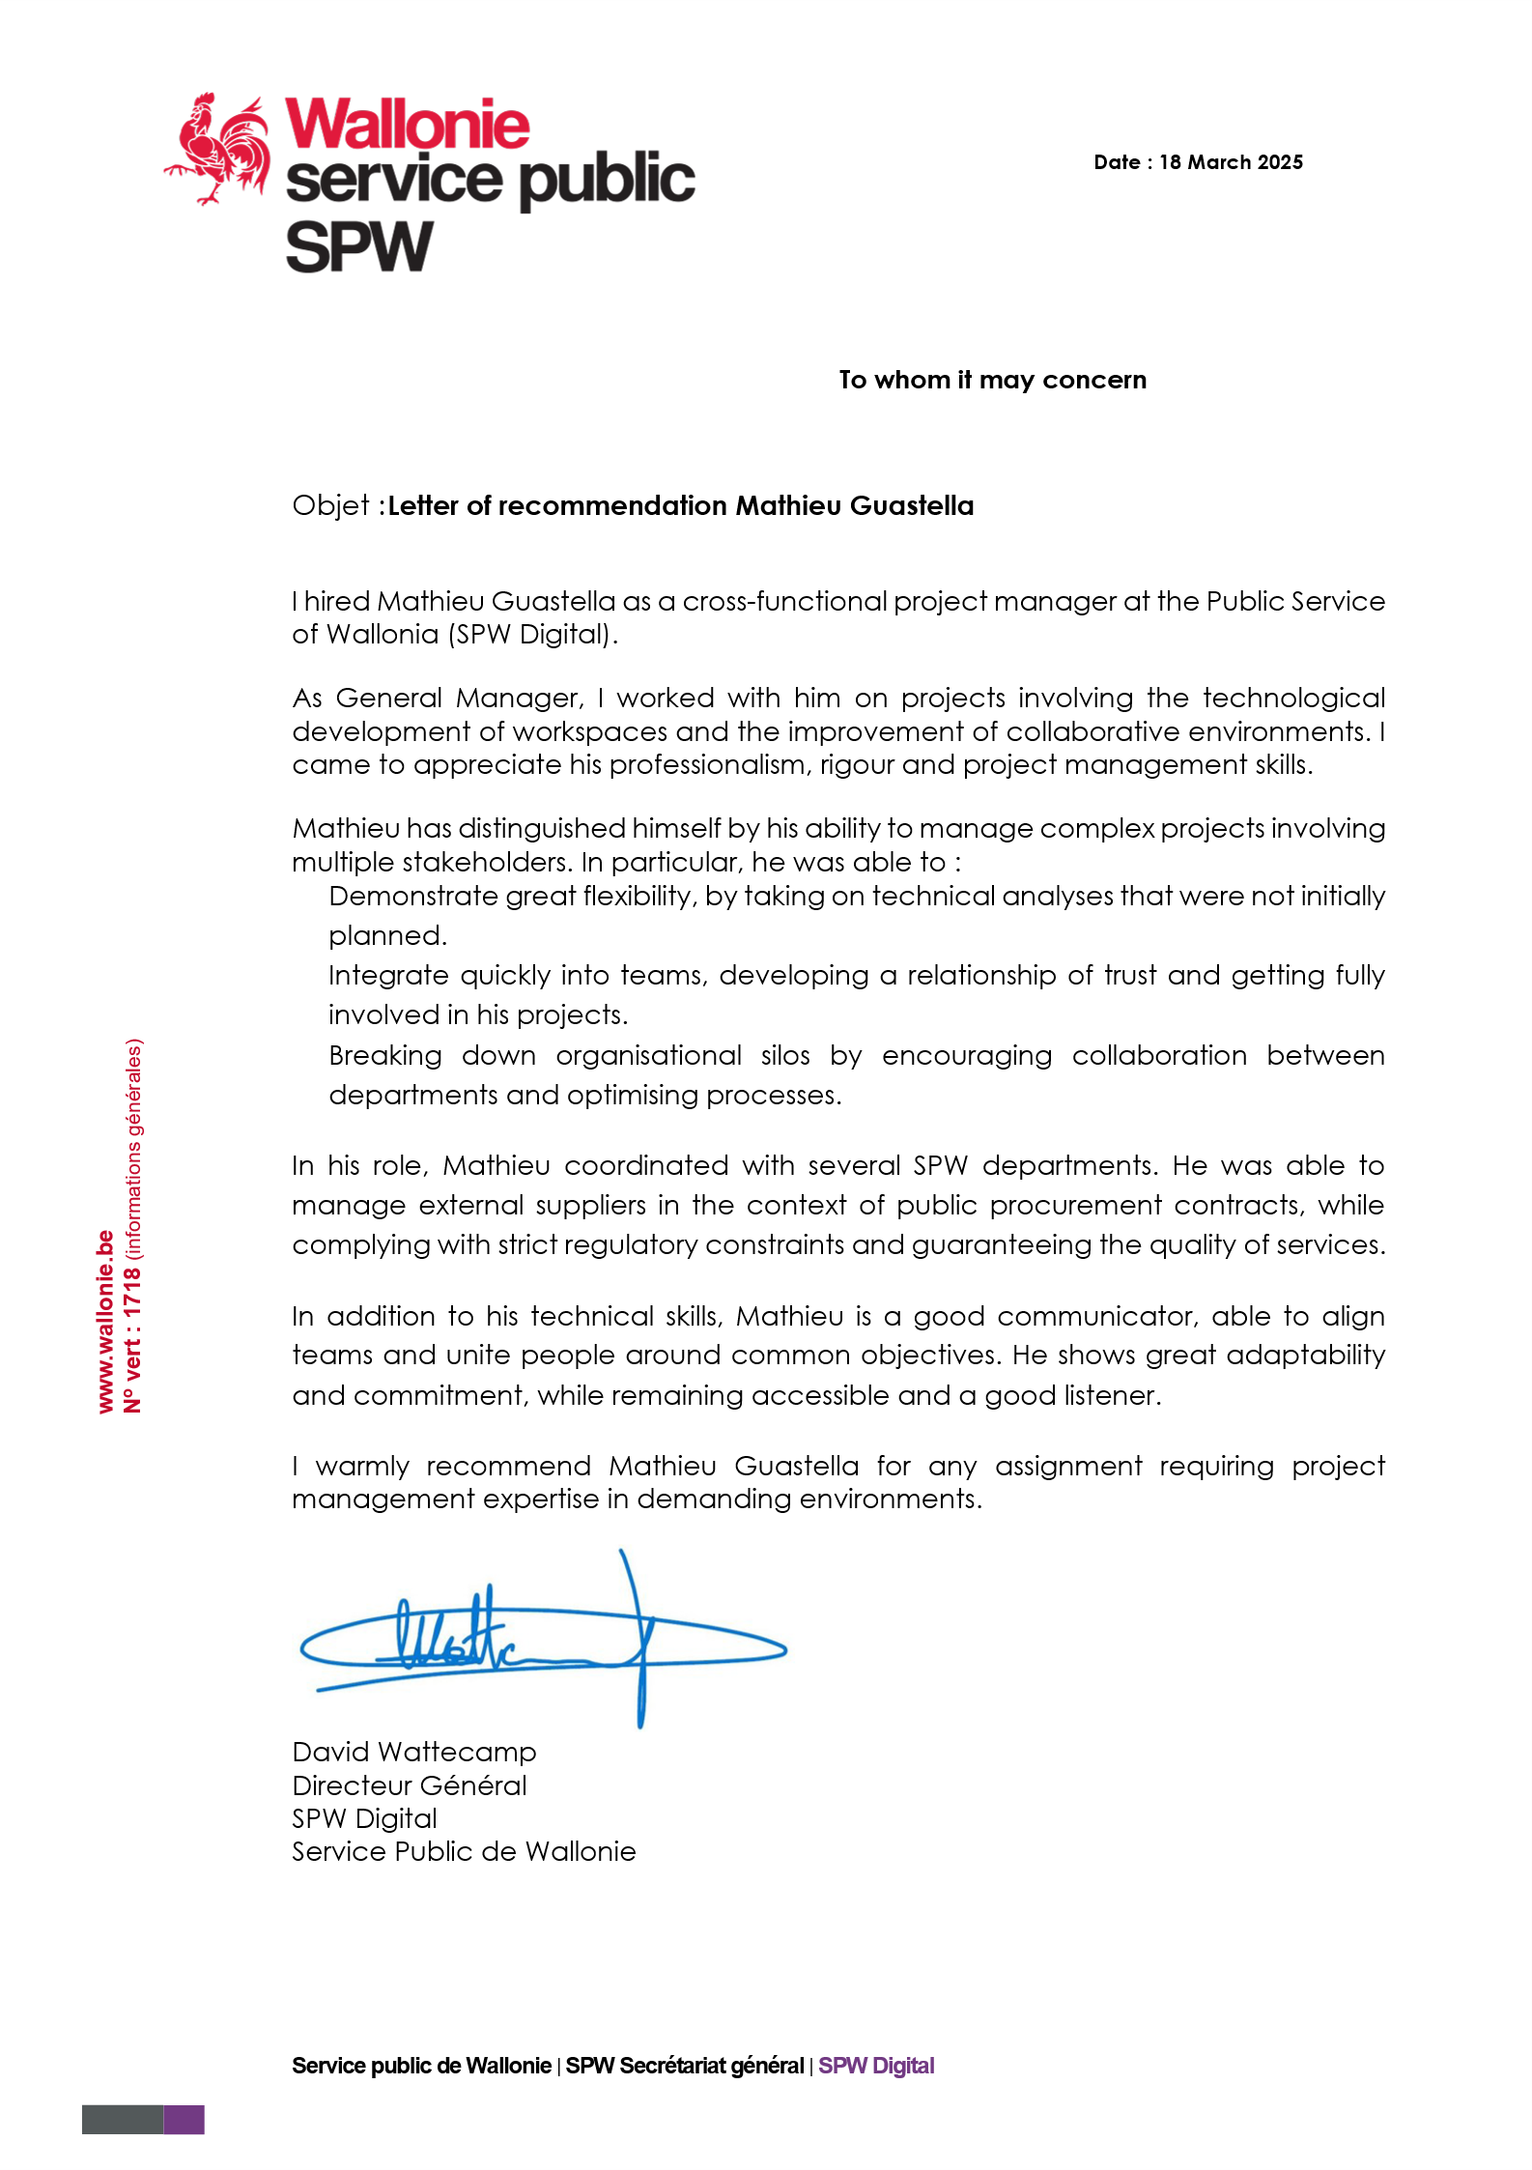
Telenet — June 2023

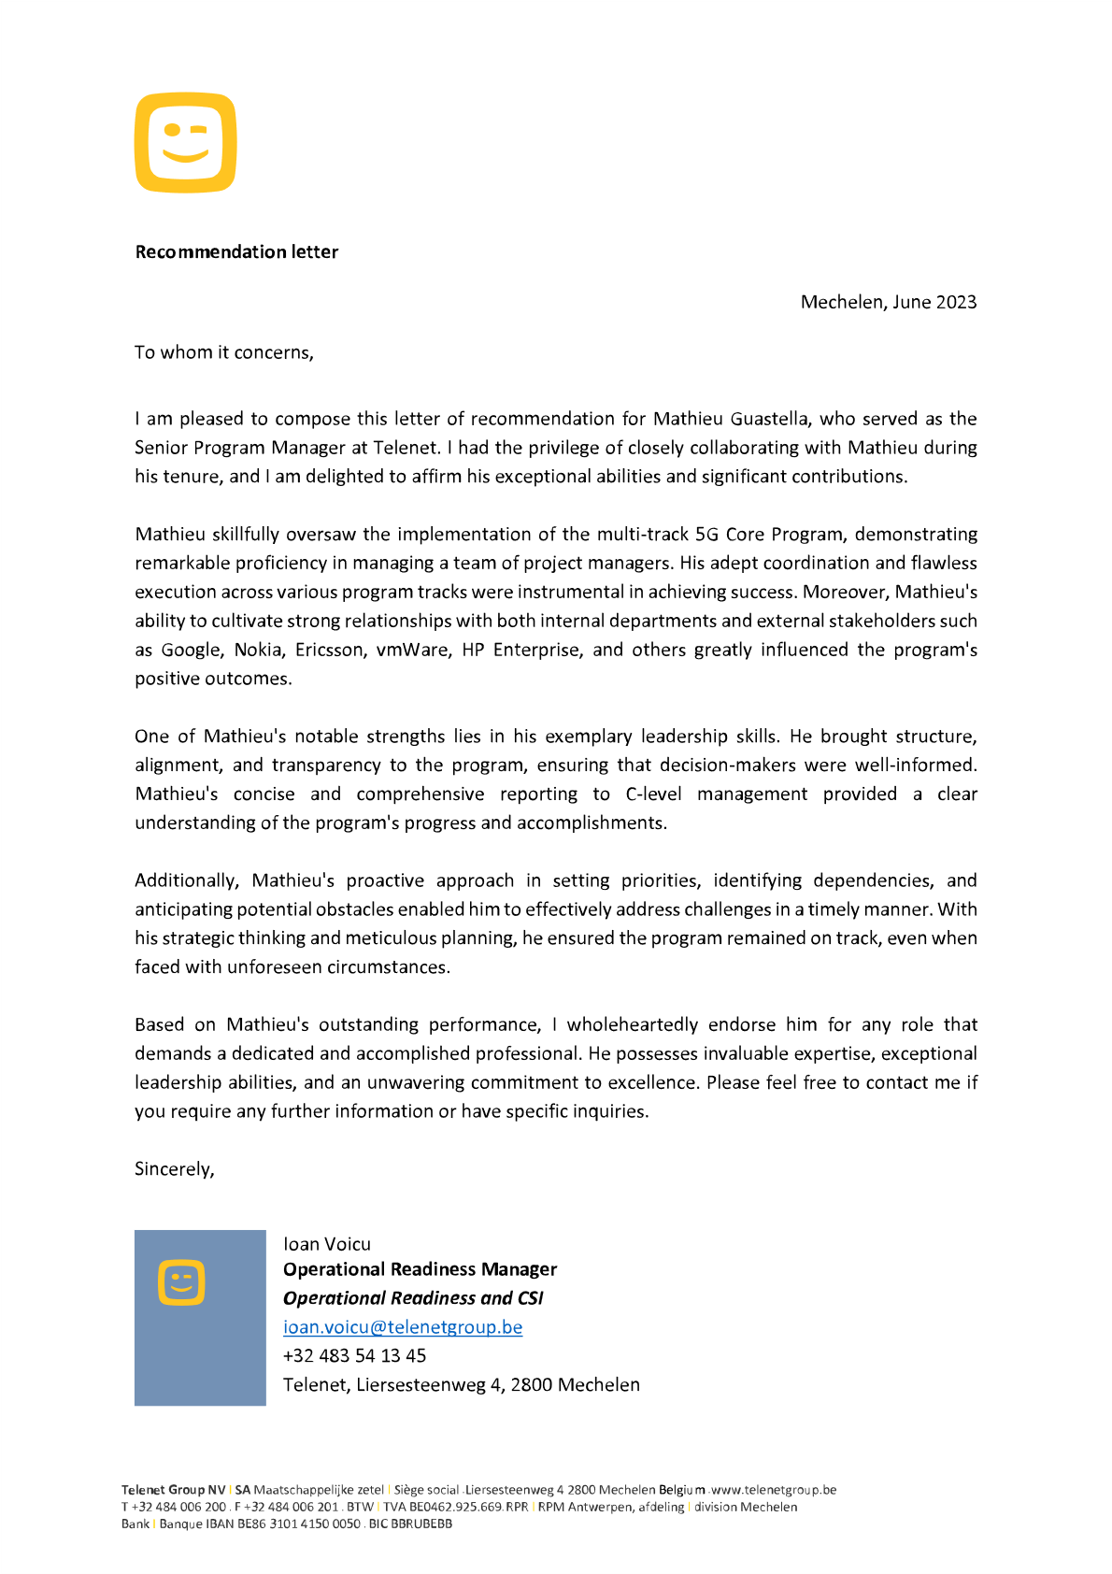

Barco — March 2022

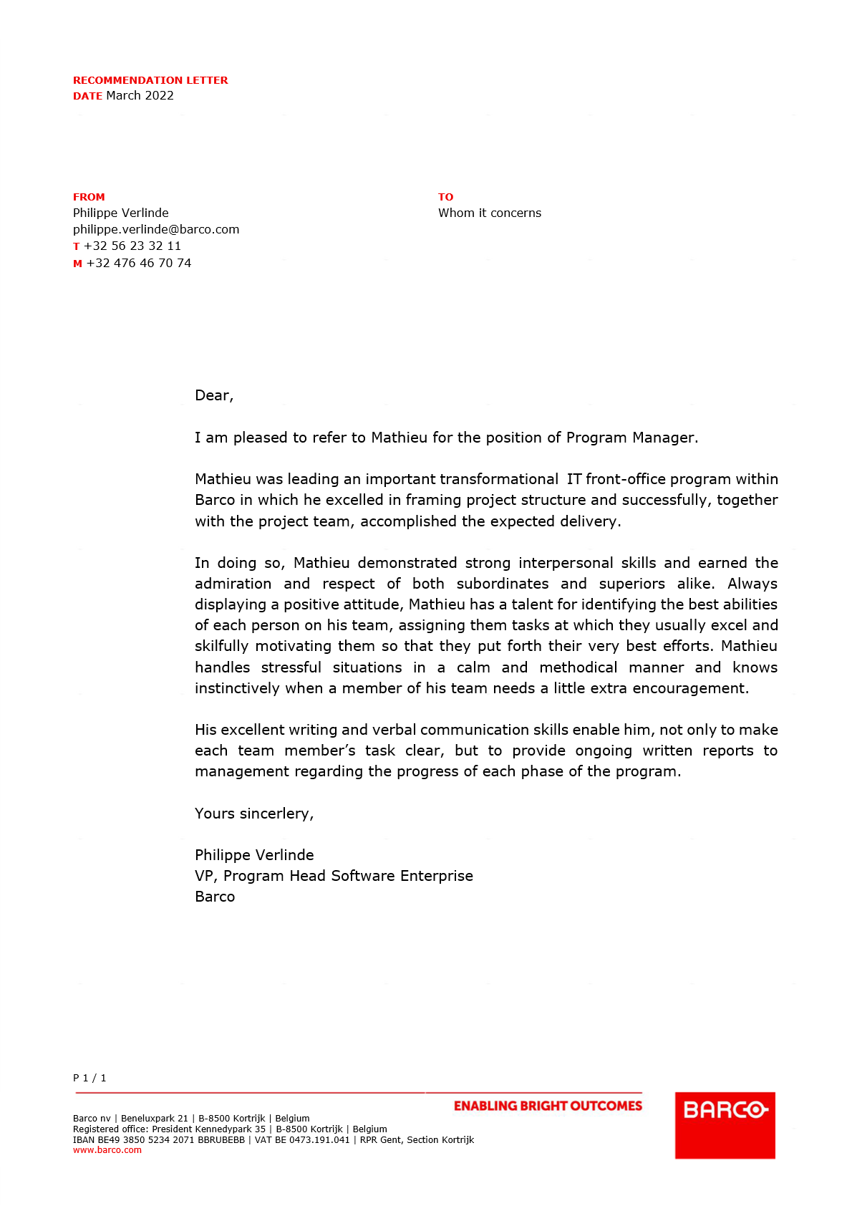

BICS — April 2021

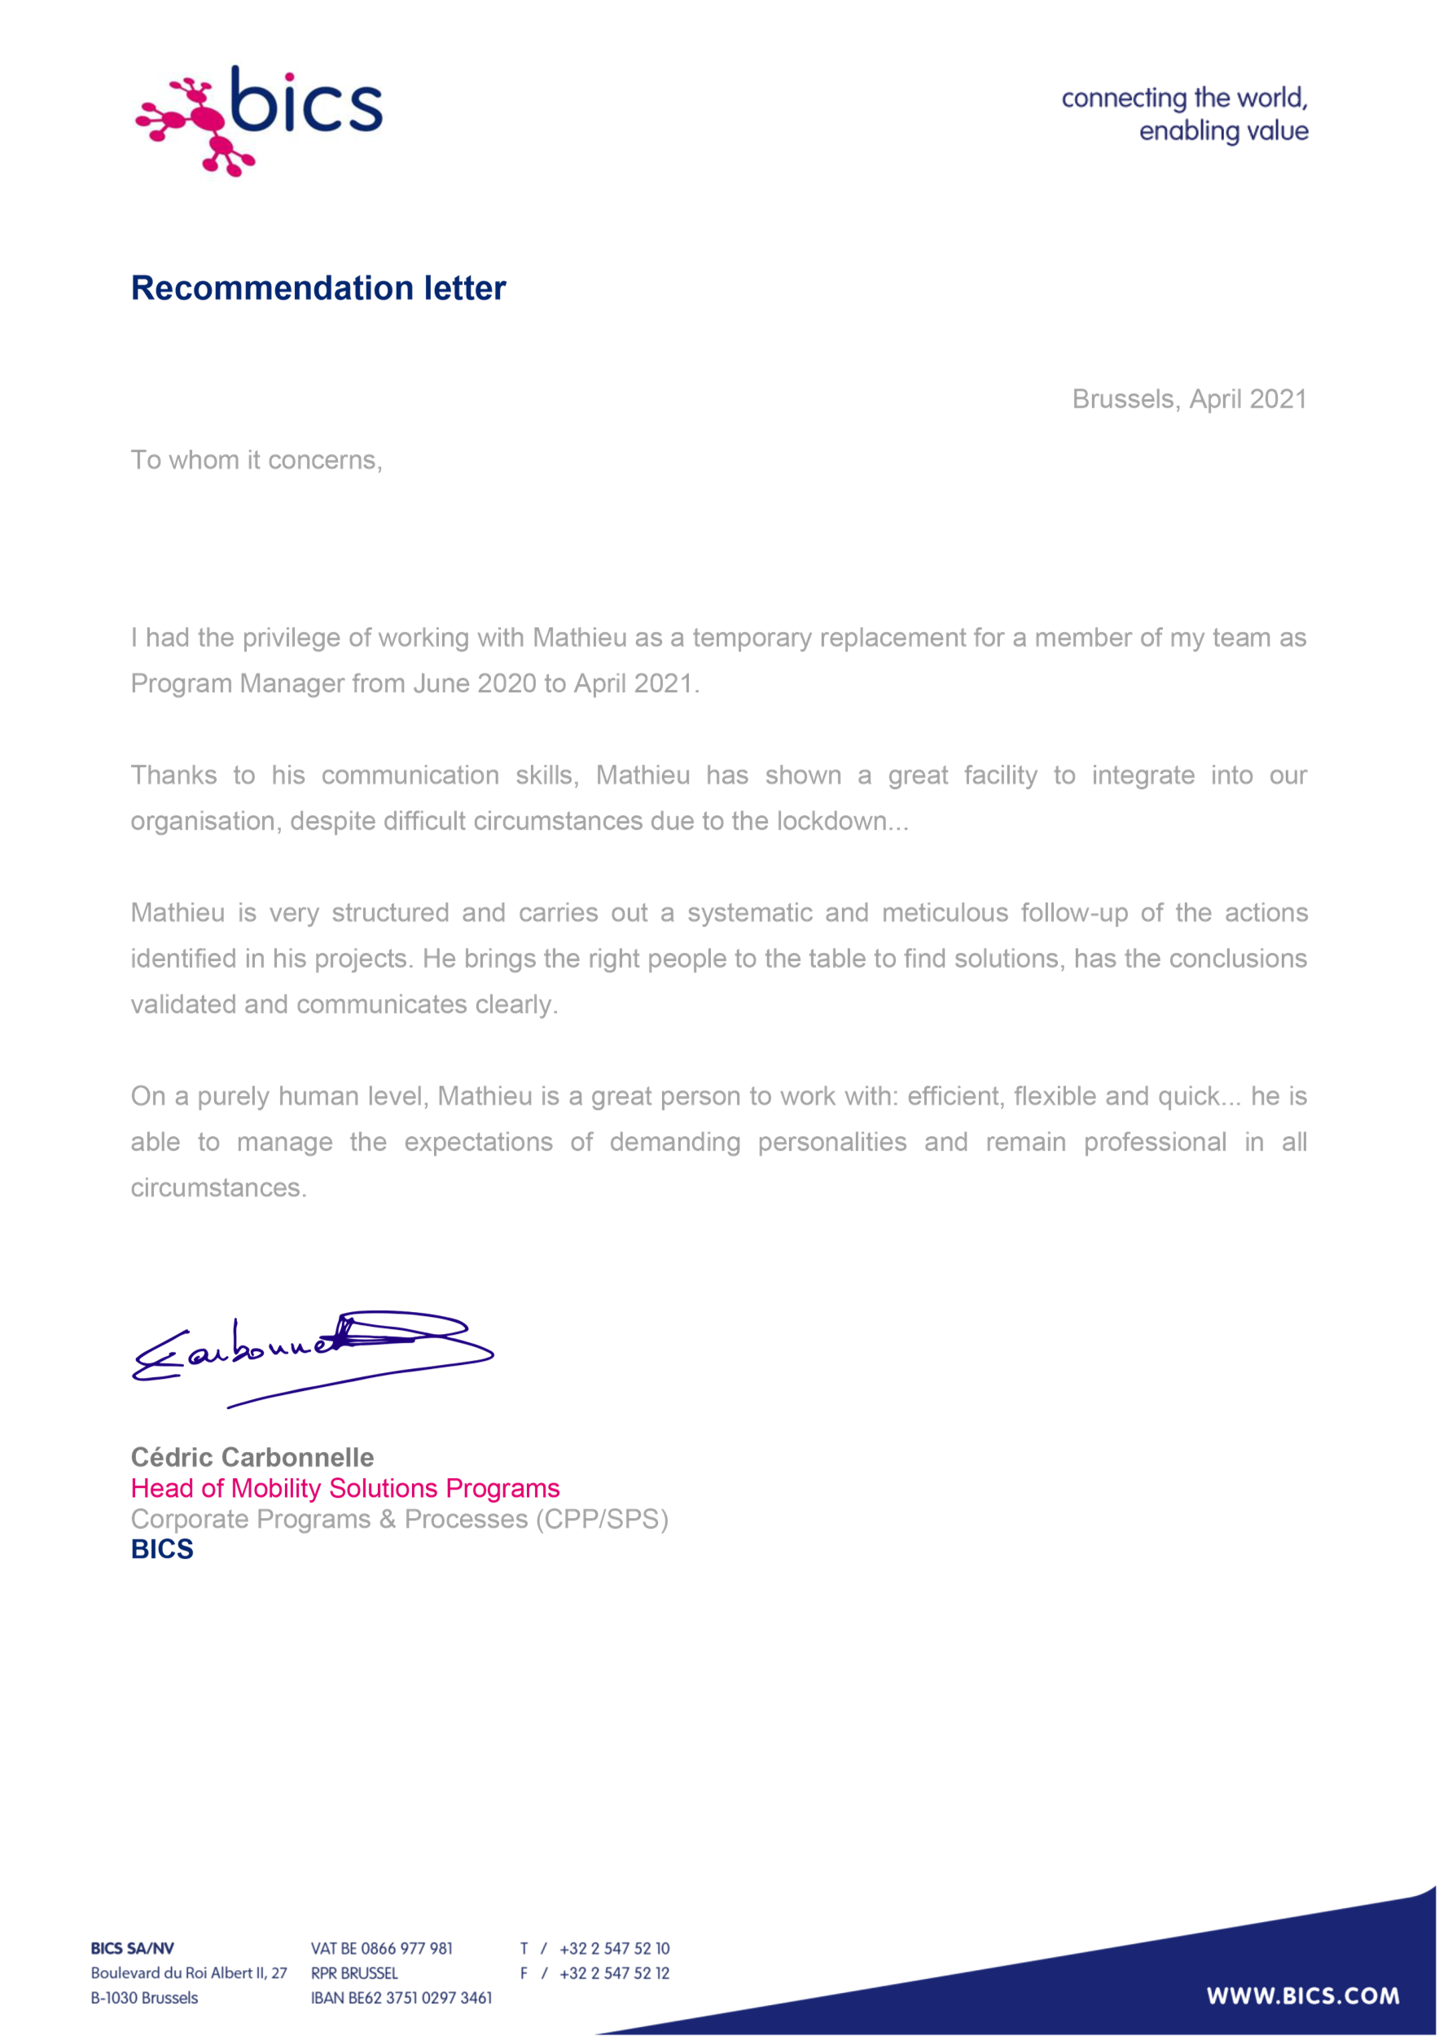
Proximus — January 2019

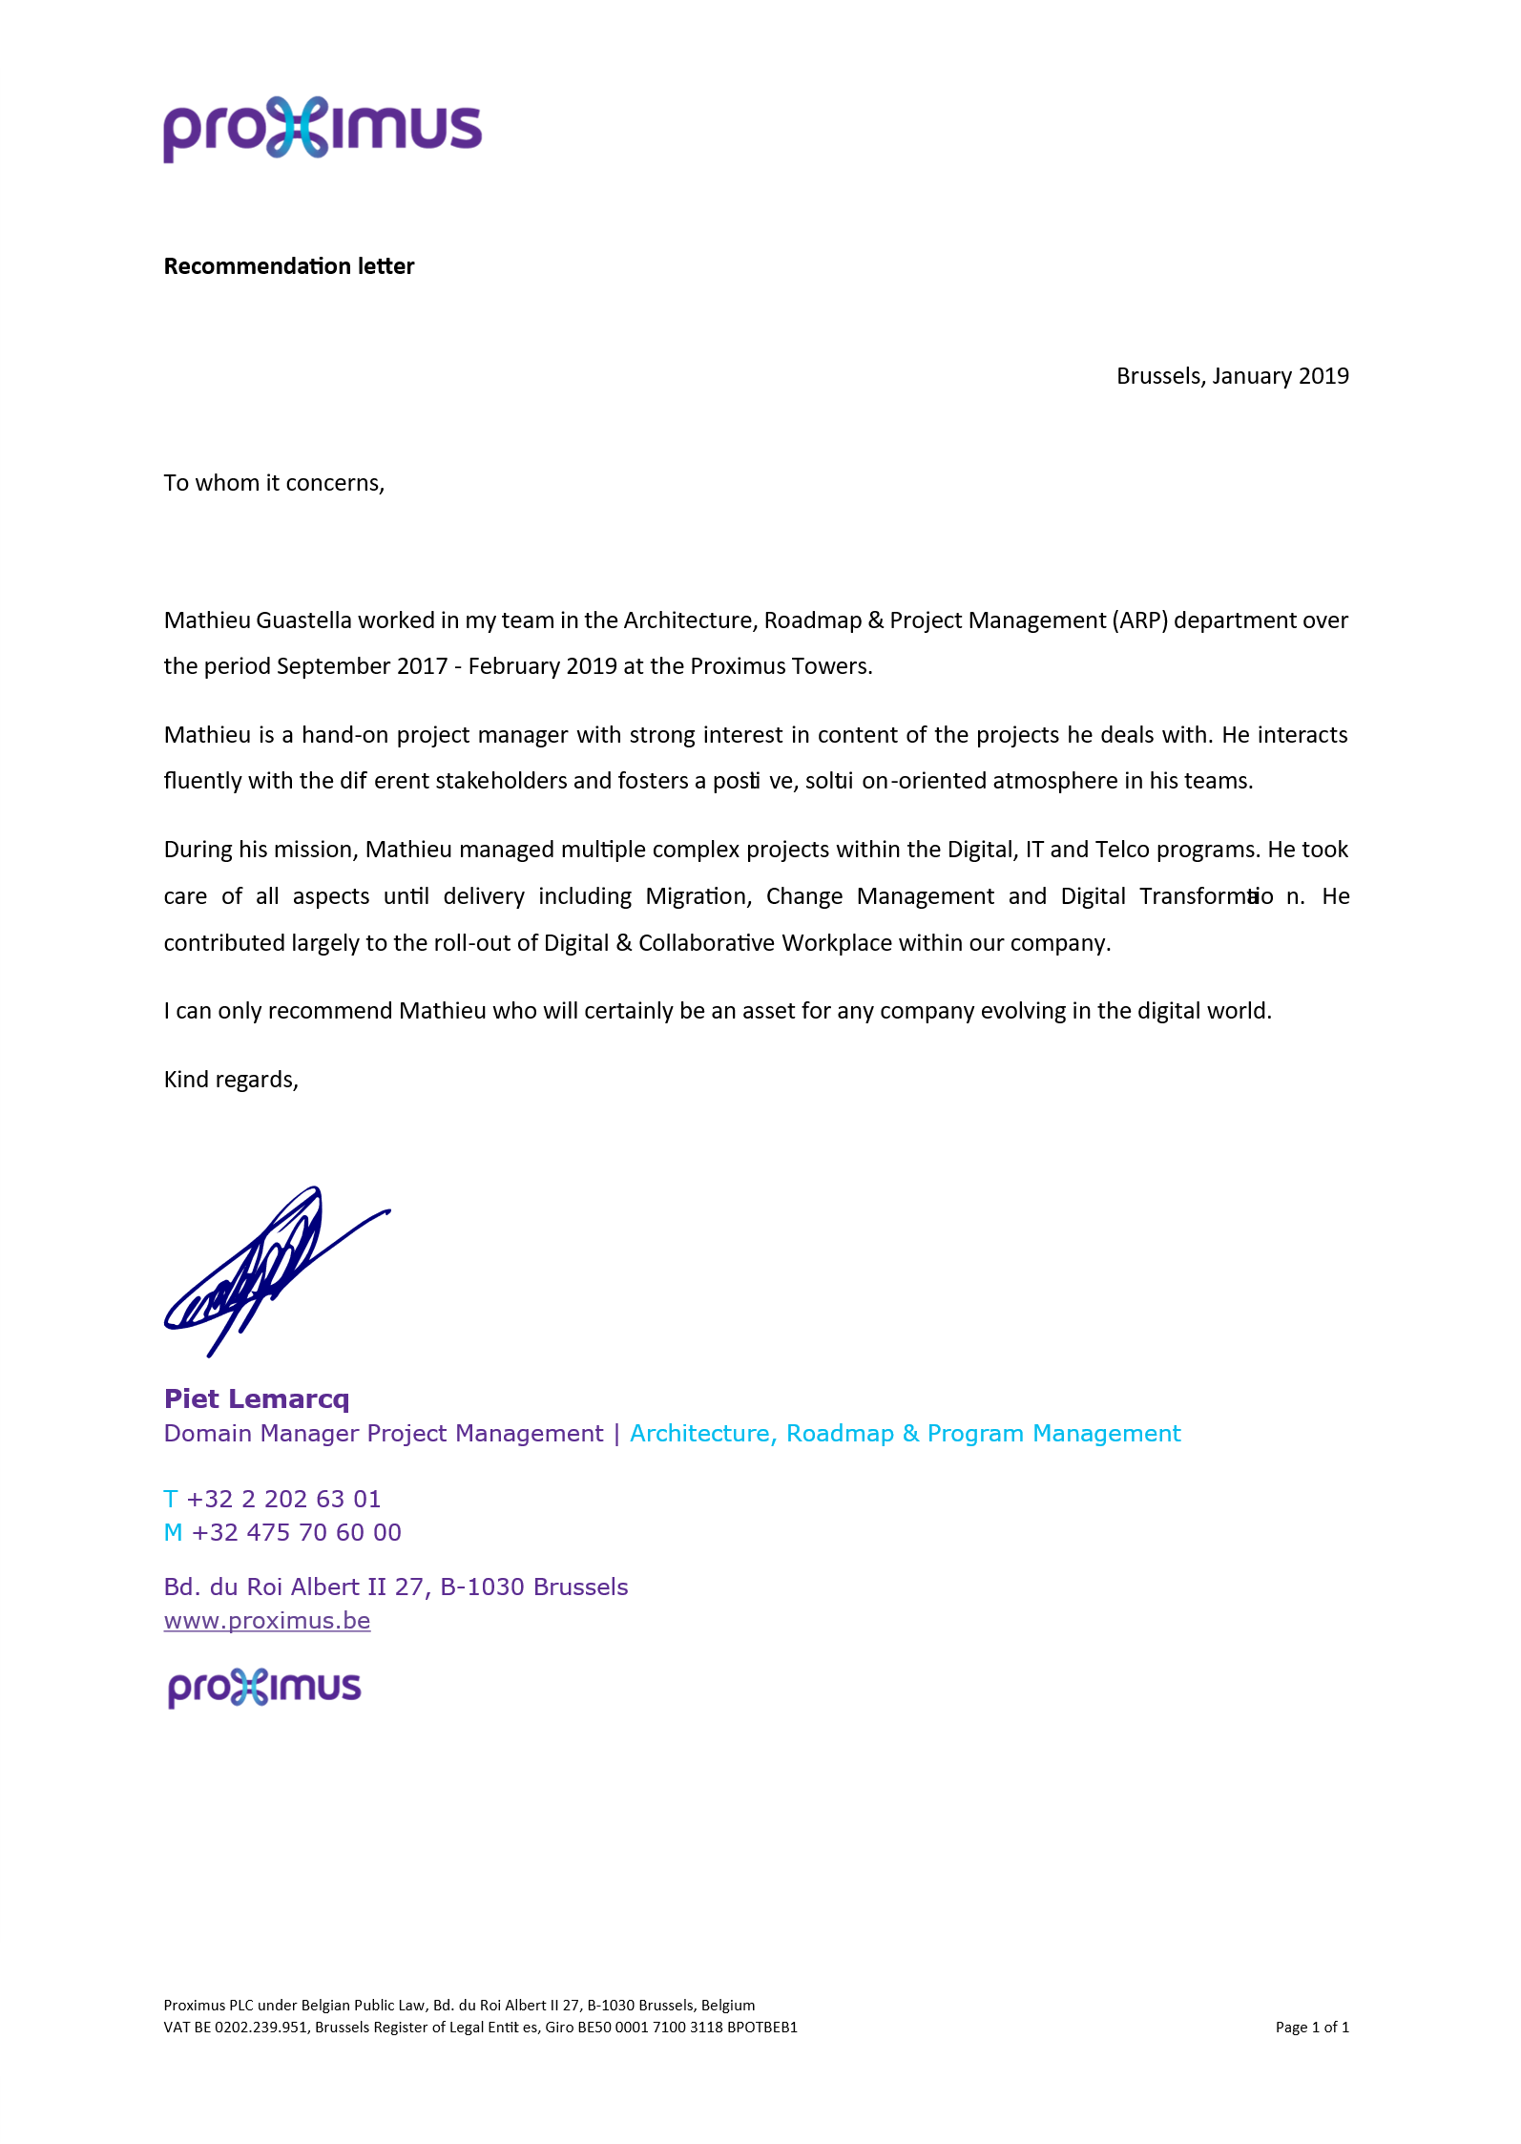

Council of Bars and Law Societies of Europe (CCBE) — January 2019

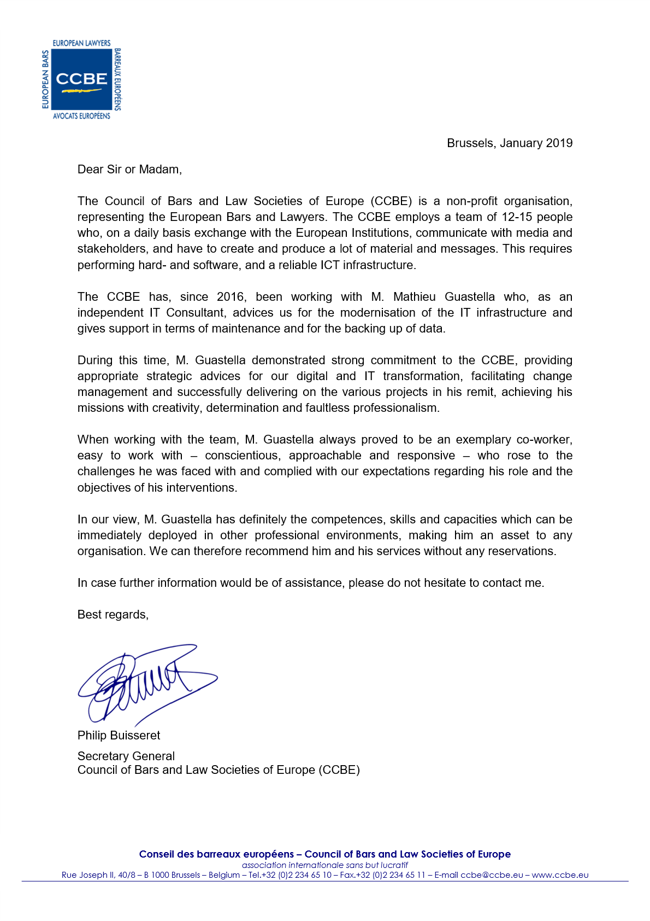

Toyota Motor Europe (TME) — August 2017

