Application File

|  |  |
| --- | --- |
|  | **Mathieu Guastella** |

**IT, Digital & Technology Consultant**

|  |  |
| --- | --- |
| Roles  CxO Service Delivery Manager Program Manager Project Manager Digital Transformation Manager Strategic Technology Advisor  Digital Marketing Manager | Sectors  Telecom/Communication Public/Government / EU Health / Medical / Pharma Banking Automotive / Industries Utilities  Advertising / Medias |

More details of my profile on [**mat.be**](https://mat.be/).

|  |  |
| --- | --- |
| **Mathieu Guastella** | mat.be  mg@nanobe.be |

  
Subject: Looking for a multi-skilled, self-learning, dynamic and efficient expert with 24 years of experience and strong communication skills who could both advise and supervise? Look no further!

Dear Madam, dear Sir,

Hereby I send you my application.

My successful professional experiences have given me the opportunity to develop my natural dynamism, curiosity, determination and enthusiasm to succeed in what I have undertaken. I have thus been able to gain rich and clear ideas about internal business processes, their needs and the financial means necessary for their performance.

After several experiences as IT Manager in different companies, I worked as Consultant, then as Project and Program Manager then as Chief Delivery Officer, which makes a total of 24 years of real experience in that domain. My assignments having been carried out in very diverse sectors, I also have a lot of experience in very different sectors such as advertising, the media, telecom, banking or even the health sector. My references and letters of recommendation in the appendix will tell you more.

As you will see on my Curriculum Vitæ, I am not limited to the skills described above. Indeed, I am also able to meet a lot of needs, and my versatility has always allowed me to be quickly integrated into an existing team.

This desire to bring my own contribution to your company encouraged me to submit a spontaneous application. Convinced that a motivation letter cannot fully describe my personality and skills, I would like to meet you in order to show how motivated I am. You will find my next availabilities as well as the possibility of making an appointment on [mat.be/meet](https://mat.be/meet).

Yours sincerely,



Mathieu Guastella

I agree to the processing of personal data provided in this document for realising the recruitment process pursuant to the Personal Data Protection Act of 10 May 2018 (Journal of Laws 2018, item 1000) and in agreement with Regulation (EU) 2016/679 of the European Parliament and of the Council of 27 April 2016 on the protection of natural persons with regard to the processing of personal data and on the free movement of such data, and repealing Directive 95/46/EC (General Data Protection Regulation).

Visual Overview Reviewed in January 2024

**Pirelli**

**Proximus**

**Council of Bars and Law Societies of Europe** (CCBE)

**Pirelli**

|  |  |  |  |
| --- | --- | --- | --- |
|  |  | 2024 | 2023 |
|  |  | **Public service of Wallonia**  **Council of Bars and Law Societies of Europe** (CCBE)  **European Commission**  **Telenet** |  |
| 2022 | 2021 | 2020 | 2019 |
| **Christian Mutuality** |  | **City of Brussels** / **i-CITY**  **Council of Bars and Law Societies of Europe** (CCBE)  **BICS**  **Unifiedpost**  **Barco** | **Orange** |
| 2018 | 2017 | 2016 | 2015 |
|  | **Toyota** |  |  |
| 2014 | 2013 | 2012 | 2011 |
|  | **All Printing Services** |  |  |
| 2010 | 2009 | 2008 | 2007 |
|  | **TotalEnergies**  **All Printing Services**  **Telemis** |  | **Xerox** |

Curriculum Vitæ Reviewed in January 2024

I. Presentation

|  |  |
| --- | --- |
| **Mathieu Guastella**  Belgian, Italian - Married, ~43 y. old  Born on 24 March 1981 in Belgium  Lives in [1380 Lasne, Belgium](https://www.google.com/maps/place/1380+Lasne) | e-mail [mg@nanobe.be](mailto:mg@nanobe.be)  Website [mat.be](https://mat.be)  LinkedIn [mat.be/linkedin](https://mat.be/linkedin)  Mobile +32 495 10 10 11 |

II. Skills, in short

• Communication • Enthusiastic • Analytic spirit • Professionalism • Rigor • Positivity •

For further details, see point IV.

III. Personality

Indicator [MBTI](https://en.wikipedia.org/wiki/Myers%E2%80%93Briggs_Type_Indicator) : [Executive / ESTJ-A](https://www.16personalities.com/estj-personality)

Indicator [Enneagram](https://en.wikipedia.org/wiki/Enneagram_of_Personality) : [Type 3w2](https://enneagram-personality.com/en/64d3934d-f244-422c-bbc1-45f795ca4579) / Chameleon

[Emotional intelligence](https://en.wikipedia.org/wiki/Emotional_intelligence) quotient (EI) : 276 [0-288] / Very high

IV. Experience

— Last missions —

**Public service of Wallonia** (SPW) Regional administration

Position **Cross-functional Project Manager**

Division SPW General Secretariat  
Department SPW Digital

Period Since January 2024

Location Namur, Belgium

Mons, Belgium

Liege, Belgium

Context

Supervision and coordination of project managers in charge of the implementation of new technologies and the move to 5 new sites in Wallonia by integrating IT, real estate and furniture aspects.

Projects

* Scope of the mission :
  + IT Equipment
  + Real estate
  + Furniture
  + Telephony
  + Videoconferencing
* Sites :
  + Namur Cauchy
  + Namur Crosspoint
  + Namur Capsud
  + Mons Renouv’O
  + Liège Paradis
* Responsabilities
  + Expertise required in special IT, audiovisual, and electricity techniques.
  + Planning, alignment of works, and management of services throughout the life cycle of premises and equipment.
  + Stakeholder management and change coordination.
  + Supervision of the teams involved.
  + Definition of “business cases” and expected benefits.
  + Supervision of all phases of the project.
  + Respect for SPW governance and project management methodology.
  + Risk analysis and proposal of measures.
  + Lessons learned based on project experience.
  + Progress reports and annual activity reports.
  + Privileged point of contact for requests for advice and support related to IT services.
  + Drafting of standards and requirements.
  + Monitoring of execution, quality control, and compliance with technical requirements.
  + Regular professional contact with internal and external customers to understand their needs and formulate avenues for optimization.
  + Direct supervision of 5 project managers
* Report directly to the General Manager

Tags Workspace VoIP Teams Videoconference Office Migration Waterfall Government Public tender Security

**European Commission** European Government

Position **Senior Project Manager**

Division DG TAXUD - Taxation and Customs Union  
Period From September 2023 till January 2024

Location Brussels, Belgium

Projects

* Projects:
  + [Import Control System 2 (ICS2)](https://taxation-customs.ec.europa.eu/customs-4/customs-security/import-control-system-2-ics2-0_en) implementation
  + Common Repository (CR)

Shared Trader Interface (STI)

* Role & responsibilities
  + Manage and follow up a set of projects in some or all their life cycle phases: inception, elaboration, construction and transition; during the software development cycle of the plan, to manage and follow up some or all activities (architecture, specifications, development, tests;
  + Enforce the quality delivery of the project according to the agreed schedule;
  + Report on the project status, escalate issue;
  + Support DEV team and Business Team by translating business needs into IT Requirements;
  + Produce and/or review documents and deliverables from contractors or other project stakeholders as well as provide suggestions for service, procedures or methodology improvements.

Tags EU Legal API Development Security Waterfall IFPUG International

**Telenet**  Telecom & television provider

Position **Senior Program Manager**

Division Technology, Innovation & Operations  
Department Business Navigation Team / Project Management Chapter

Period From November 2022 till August 2023

Location Mechelen, Belgium

Context

Strengthen the project team by improving the communication, governance, structure of collaboration and planning & dependencies consolidation.

See recommendation letter below.

Projects

* 5G Core rollout (Including 5G stand-alone)
  + Packet Core (Including Tadaam capacity increase)
  + Telco Cloud
  + SDM (HLR+HSS+UDM)
  + Lifecycle Automation & Test Automation
  + Security
* Involved departments :
  + TIO — Technology, Innovation & Operations
  + C&I — Cloud & Infrastructure
  + I&E — IT & Engineering
* Coordination of international external vendors
  + Nokia
  + Google Anthos
  + Ericsson
  + HP Enterprise (HPE)
  + vmWare
* Responsabilities
  + Proposal and implementation of a new governance and structure
  + Deliverables revision & consolidation
  + Transversal communication
  + Organization of internal and external Steercos
* Methodology
  + Telenet Agile Way of Working (TAWoW)
  + Working in Agile Squads
* Team leadership
  + Supervising 4 projects managers
  + Reporting to Chief Product & Technology Officer

Tags 5G vmWare GoogleAnthos Agile C-Level International Security

**Christian Mutuality**  Healthcare mutuality & Social secretary

Position **Service Delivery Manager**

Department ICT

Period From May till November 2022

Location Brussels, Belgium

Context Reinforcement of management until transfer to a permanent role.

Projects

* Development of the vision
* xRM (Integrated CRM)
  + Oracle CRM Migration
  + Global roadmap vision
  + Agile methodology
* OCT (Omni Channel Tool)
  + Multichannel call-center integrated solution (calls, recordings, e-mail, chatbot, social network, …)
  + Managing 35 000 calls/year
  + External vendor integration (Genesys, Siebel, Verint, Calabrio, Clarabridge, Digitalflow, Amazon Connect…)
  + Synergies with bpost and KBC
* 5,5M total managed budget
* People management
  + 70 employees
  + Hirings and dismissals in Belgium and abroad
  + Timesheet approval
  + Holidays management
  + Evaluation & progress (Berenschot methodology)

Tags HR CRM VoIP Agile Development Infrastructure Public tender

**Barco**  Medical devices & Images processing

Position **IT Program Manager**

Department Strategic Initiatives / CDIO Organization

Period From December 2021 till April 2022

Location Kortrijk, Belgium

See recommendation letter below.

Context

Temporary replacement of employee being there for 10 years until they find a permanent profile.

Projects

* Digital Engagement:
  + CRM 2.0 - Migration from SAP CRM to SalesForce
* Corporate functions:
  + E2E Service (moving functionalities from SAP CRM & SAP ERP to SAP ECC)
* Data:
  + ODS - Operational Data Store (SAP ECC, SAP BYD & SalesForce to Azure)
  + BI - SAP EWM
* Logistics & Manufacturing
* Infrastructure & Operations
* Reporting to CDIO (Chief Digital & Information Officer)

Tags SAP SalesForce CRM BI API Azure Security Agile

**Unifiedpost**  Digital Bank

Position **Chief Delivery Officer**

Department Payments

Period From March till November 2021

Location La Hulpe, Belgium

Timișoara, Romania

Bucharest, Romania

Cluj-Napoca, Romania

Warsaw, Poland

Hồ Chí Minh, Vietnam

Context

Creation of the Delivery department by splitting the Product dept after the IPO followed by handover to a permanent employee.

Projects

* Acting as Service Delivery Manager, Team Leader & PMO
* Steering of the global delivery roadmap
  + PowertoPay — Online Payment Services
  + OCS — Online Collection Services
  + itspaid
  + CAF — Capture and Forward
  + IBIS — IBAN Payments Accounts
  + PXG — PSD2 XS2A Gateway
  + Albatros — Onboarding, Customer Due Diligence & Provisioning
  + Banqup / Billtobox / Banqware
* Leading international teams at Program & HR level composed by :
  + 8 Delivery Managers
  + 8 Architects
  + 58 Developers
  + 15 Testers
* HR Sourcing
* Reporting directly to the CEO
* Working with international external vendors

Tags HR C-Level Banking Agile Development International Security

**BICS** International roaming provider

Position **Program Manager**

Department Corporate Programs & Processes / Service Platform & Solutions (CPP/SPS)

Period From June 2020 till April 2021

Location Brussels, Belgium

See recommendation letter below.

Context Replacement of a woman on maternity leave, and then of a second.

Projects

* Portfolio Management
* Roaming Evolution Program
  + Roaming platform deployment
  + Business Roaming Trading Tool (RBMT/ROAMT)
  + MVNE
  + Roaming OSS/BSS roadmaps
* IoT
  + Direct IoT discount management
  + Tomia
  + Topaz
* Roaming Domain
  + 1-2-1 IMSI Mapping implementation (light, full & capacity increase solutions)
  + 5G NSA support for Xsphere
  + VoLTE
  + Generic Pricing Tool (GPT)
  + Instant Roaming (IR)
  + Productization NB-IoT and LTE-M
  + Amazon Marketplace (AWS) & Microsoft Azure integration
  + Signa software conversion to ReactJS
  + OC Roaming peering agreement with Orange

Tags 5G Agile Waterfall Development International Security

**City of Brussels** / **i-CITY** Government

Position **Digital Transformation Program Manager**

Period From July 2019 till March 2020

Location Brussels, Belgium

Context

Proximus won the public tender and contacted me back since I have made a similar work for them 5 months before.

Projects

* Digital Transformation Program NWoW (New Way of Working)
  + Migration to Skype for Business, Teams, Office 365 & Windows 10
  + Unified Endpoint Management
* Support each department of the city as internal customers to
  + Implement the planning
  + Facilitate the integration
  + Consolidate and organize the required data
  + Inform and validate governance with each stakeholder
  + Communicate with impacted end users
* Develop tools and improve process to
  + Apply lessons learned
  + Optimize communication
* Coordinate the technical team during each migration phase
* PMO role

Tags Workspace VoIP Teams Windows Office Migration Waterfall Government Public tender

**Orange** European telecom operator

Position **Domain Manager IT, Telco & Billing Systems**

Department Customer Factory

Period From March till July 2019

Location Evere, Belgium

Chișinău, Moldova

Projects

* Mediation Domain
  + Transition from ADMS services supplier TechMahindra (India) to Orange Moldova (Moldova)
  + Knowledge transfer & training sessions management
  + CDR transformation and aggregation
  + Operating & Working Level Agreement definition
  + Steerco presentation(C-Level)
* Revenue Assurance Revamp
  + Analytical audit data

Tags HR OSS BSS CDR Billing Training Waterfall Agile International  Security

**Proximus** National Belgian landline phone, mobile and digital services

Position **Program Manager Digital & Collaborative Workplace, IT & Telco**

Department Architecture, Roadmap & Project Management (ARP)

Program Telecom, IT, Digital Workplace & Collaborative Workspace

See recommendation letter below.

Period From September 2017 till February 2019

Location Brussels, Belgium

Projects

* Digital Transformation Program
* Migration from Cisco to Skype for Business
* Implementation of a new Intranet platform: #WAP (We Are Proximus)
  + Integration of OASE as data provider
  + Based on the Jive platform in partnership with the parent company Aurea
* Implementation of marking, classification and encrypting solutions for documents and e-mails
  + Microsoft AIP/RMS based on Microsoft Azure AD authentication mechanism
  + For Office 365, Sharepoint & OneDrive
  + Management of data sharing with external partners
  + Audio, Video et Videoconference (AV/VC) solution deployment
  + Cisco Spark & Room Kit, Crestron AM101, Mercury & AirMedia
  + Wireless systems
* Migration to Office 365, Windows 10 & Microsoft Teams
* Proximus TV
  + Streaming services integration
  + Internal & external stakeholders management
* SmartOffice Implementation
  + Collaborative space and meeting rooms with real-time availability management
  + IoT & Lora sensors used for optimization of meeting rooms and collaborative workplace
  + In partnership with MapIQ
  + Counting of floors occupancy using smart cameras.
  + Integration of a virtual remote access based on the Awingu platform
  + Migration from Citrix & VNI environments
* Implementation of the cybersecurity policy
* Implementation of a video broadcasting video
  + Based on Microsoft Stream
* Implementation of SMS routing to fix numbers
  + In collaboration with BICS
* Extended Implementation of these projects:
  + Proximus SA
  + Proximus Group: BICS, Telindus, SpearIT, Scarlet, Skynet iMotion Activities, Unbrace, ConnectImmo, Be-Mobile, Tango, Davinsi Lab, Codit, …

Tags Workspace Migration Teams Office Windows Security Training Videoconference Waterfall Agile

**Toyota Motor Europe** Car manufacturer

Position **Project Manager Telematic & Multimedia**

Department Business Strategy

Program Connected Car

See recommendation letter below.

Period From March till September 2017

Location Evere, Belgium

Munich, Germany

Düsseldorf, Germany

Projects

* Toyota Supra 2019 (A90) connected services
  + Learning of technology integration with BMW manufacturer
  + Negotiation of after-sales maintenance needs
* Implementation of E-Call for the European market
  + Negotiation with telephone operators
  + Acquisition of 1M SIM cards from Vodafone
* Development of a fleet traceability system for the insurance market
  + Definition of technical needs and facilitation between business and engineers
  + Development of equipment to collect data

Tags Industrial Legal Negotiation Procurement Process International Waterfall

**Council of Bars and Law Societies of Europe** (CCBE)

European association of lawyers for the promotion of law and justice

Position **Strategy & Technology Advisor**

Period Since 2015

See recommendation letter below.

Projects

* Implementation of a new file server
* Deployment of an antivirus solution
* VoIP telephony migration
* Migrating emails from Exchange to Office 365
* Implementation of Skype for Business
* Archiving solution with OCR
* Migrating Skype for Business to Microsoft Teams
* Maintenance of the IT equipment including server and infrastructure

Tags EU Legal Strategy Negotiation Procurement Process International

**Licence Plate Belgium** Web site of Belgian customized licence plate

Position **Founder & Full stack developer**

Period Since 2014

Projects

* Database design, setup and management
* PHP, CSS, HTML, Javascript, Ajax, …
* Automatic licence plate recognition (ALPR)
* Licence plates generator

Tags Development Legal PHP HTML CSS PDF Bootstrap Framework Agile

**Pirelli** Tyre manufacturer

Position **ICT, Digital & Marketing Development Manager**

Period From January 2013 till January 2017

Location Brussels, Belgium

Projects

* Implementation of the EDI protocol
  + In order to allow digital transactions
* Telephony migration
  + Implementation of Cisco solutions
  + Call Center management using Genesys et interconnections with SAP
* Automation of the pricing system
* Windows migration (clients and servers)
* Implementation of the national commercial website
* Marketing campaign management
* Implementation of Microsoft Dynamics CRM
* Supervision of the office relocation
  + IT
  + Connection technology
  + Telephony
  + Security systems

Tags IT Marketing Administration EDI API XML Dynamics Event International Security

— Previous Missions —

**All Printing Services** Press, printing and copies

Position **Project Manager**

Period From November 2009 till December 2012

Projects

* Development of a complex price calculator
* Solution for transferring daily bank data between various points of sale to the head office
* Development of an SMS notification system
* Implementation of a telephone central system with a personalised welcome menu
* Process optimisation
* Migration of Office 365

Tags Development Infrastructure PHP HTML CSS PDF SMS FAX Agile

**TotalEnergies** Lubrification and distribution of petroleum products

Position **Project Manager**

Period In 2009

Projects

* Supervision of the development of a real-time oil barrel price diffusion system
* Information interfacing for different media (web, TV, …)
* Deployment of the solution in the 9 call centers in Belgium

Tags Development Infrastructure Marketing IIS HTML CSS International

**Telemis** Medical imaging solutions

Position **Project Manager**

Period From 2007 till 2008

Projects

* Access security by authentication via RSA SecurID
* Implementation of a for material management and logistics follow-up
* Monitoring of customer sites

Tags Medical IT Security Procurement Development Infrastructure International

**Xerox** Imaging and printing solutions

Position **After-Sales Manager**

Period From 2006 till 2007

Projects Supervision of material implementation projects with customers

Tags Infrastructure IT Security SMTP DNS DHCP VLAN Network Integration International

— Older Missions —

**Cando** Event organisation

Position **Project Manager**

Period From 2005 till 2007

Projects Network management of 200+ computers and Windows migration.

**Mondo Chemicals** Chemical production

Position **Project Manager**

Period From 2004 till 2005

Projects Supervision of offices relocation, migration, installation of security cameras, telephony, …

**European Patent Office** European office of patent registration and regulation

Position **Project Manager**

Period In 2004

Projects Organisation and supervision of international events

**Solid Partners** Consulting in Business Intelligence

Position **IT Manager**

Period From 2002 till 2003

Projects IT maintenance, migration of servers, customised developments, …

**Nanobe Corporation** Telecom and IT consulting

Position **Founder / CEO**

Period Since 2002

Projects Corporate consulting, outsourcing

Complete list of customer references in attachment.

**Field Resource** Field services for advertising placement

**Alizé Média** Advertising management

**Mood Media** Commercial audio broadcasting

**Publiroll** Advertising management

Position **IT Manager**

Period From 2000 till 2002

Projects Installation of servers & domain, administration, help desk, webmaster, ...

V. Skills, in details

Although these skills may be quite different, each was carefully studied and actually implemented on various occasions, and not quickly read.

Soft skills

* Excellent interpersonal and communication skills
* Entrepreneurial attitude
* Solution & action oriented
* Diplomatic, flexible and team player
* Ability to convince
* Ability to work with executives
* Client Minded & Focus
* Capacity to gain trust and confidence
* Create climate where people feel motivate
* Capable to have a good strategic overview
* Capable to focus on the means to action to reach the objectives

Project Management

* Agile, Scrum, Waterfall, Prince 2, …
* Microsoft Project, PlanView, Rapid, …
* Jira, Trello, Confluence, Asana, Wrike, ClickUp, Monday, Aha!

Network

* PC, Mac, Qnap, Synology, Unifi
* Servers : Windows Server, Exchange Server, Mac OS
* Virtualization: Hyper-V, vmWare Workstation, ESXi, vSphere, Cloud Computing
* DNS, DHCP, Load-balancing
* PXE Boot, Automated deployment, Group Policies

Web

* PHP, HTML, CSS, ASP
* Web Services, AJAX, API, EDI, EDI Wheel, Geolocalisation, Traduction
* jQuery, Prototype, Scriptaculous, MooTools, LightBox, Bootstrap…
* WordPress, SugarCRM, Joomla, Drupal
* Microsoft Azure, Amazon Web Services (AWS), Google Cloud Platform (GCP)

Database

* PowerBI, PowerQuery, SAP, CRM, SalesForce, Access
* MySQL Server, SQL Server
* Reporting, Geo-marketing

Security

* Firewall, routeur, VPN, IT Forensic
* Dual-factor authentication, RSA SecurID
* Data backup, redundancy, load balancing
* IP cameras, badging systems
* NTFS, Encrypting WEP, WPA, AES/Rijndael 256

Graphics & Multimedia

* DreamWeaver, Illustrator, Photoshop, Light Room, InDesign, Final Cut Pro, Plex Media Server

Programming

* PHP, JavaScript, Visual Basic, VBA

Automation

* IA, Chatbot, ALPR
* AutoMate BPA Server, Mozenda, Scripting divers

Telephony

* Lynk, Skype for Business, Teams
* Cisco Unified Communications, Siemens Manager C & E, HiPath, Alcatel VMS, Forum
* Mediation, VoIP, Fax, SMS

VI. Education

YEAR ACQUIRED EVENT / ORGANIZATION

2023 IT Security European Commission / QA5 Security Team

[Leading with a Heavy Heart](https://www.linkedin.com/learning/certificates/a091cc9edc64447c4fd71d6eccc249ee2cab7c1b154cdf63534534c03a361198) Kat Cole / PMI

[Leading with Vision](https://www.linkedin.com/learning/certificates/4a713a41700ef2547680448f84debf044c996c1932f57a55db6d9c0b4753b378) Bonnie Hagemann / PMI

[Interpersonal Communication](https://www.linkedin.com/learning/certificates/98cffe592ebf3b4150e2475a8211e857b719e884bd754b0f9e4b4412023fb0d0) Dorie Clark / PMI

[The foundations of Machine Learning](https://www.linkedin.com/learning/certificates/f4dfce985d632209457c744f4d8a76f5e11e1fcdf3c970ba78feeab4df24dd44) Vincent Isoz

Generative AI learning path Google Cloud Skills Boost

2022 Microsoft Teams Calling Microsoft / Proximus

2021 [Develop your emotional intelligence](https://www.linkedin.com/learning/certificates/c39312a6f5c721705ce43e9a0d0d2a3f43698947c76e0534811537678bdfd1ec) Jean-Marc Pairraud / PMI

[Communicate with diplomacy and tact](https://www.linkedin.com/learning/certificates/f08503e0d8847aa2c3c3bf1a1098765bbd5a2415c35b9cd7df7368e1a5e0529c) Jean-Marc Pairraud / PMI

[The foundations of communication](https://www.linkedin.com/learning/certificates/c4c1d34f1fd0cca5f33e72b2f56dc5a9edd734b2d463988826fa1025e101991a) Rudy Bruchez / PMI

[The foundations of NLP](https://www.linkedin.com/learning/certificates/45e983714a5cd18044db698236587b95dbf07aebd579a113c10a9b99047bd975) Rudy Bruchez / PMI

Porsche Track Experience — Warm-up training Porsche Experience / RACB

[The foundations of blockchain](https://www.linkedin.com/learning/certificates/de0683cd5c063d212af01b3bf77a77bcda4eb5068822701184653d16c8238c04) Jonathan Reichental

[Design and implementation of cryptography](https://www.linkedin.com/learning/certificates/4fa43068524feadc87682554f05005bf1b392b5fa0824b66d457514b0b962cdf) Mike Chapple

Microsoft Teams & Calling Microsoft & Proximus

2018 IoT – Internet of Things Proximus Corporate University

GDPR Proximus Corporate University

Agile Proximus Corporate University

2017 Rapid Proximus Corporate University

Jira Proximus Corporate University

SunShine Proximus Corporate University

Permis de conduire véhicules prototypes Toyota Motor Europe / RACB

Apple Certified Professionals APPL272872 Apple

2015 Microsoft Office 365 Microsoft

Migration and maintenance training.

Microsoft Office 2016 Microsoft

Microsoft Windows 10 Microsoft

2014 Microsoft Dynamics CRM Avanade

2013 B2B Pirelli

EDI Pirelli

2012 MacOS Lion Apple

Final Cut Pro Apple

2011 Windows 8 Microsoft

2010 Cloud Computing Microsoft

Virtualization & Managed Storage Dell

Strategic deployment training

2009 Virtualization Intel

Installation and maintenance training

2007 Xerox Integrator Knowledge Xerox Knowledge Center

Installation and integration training on Xerox copiers, fax and scanners devices

2006 Storage & Backup Solutions Symantec Knowledge Session

Storage and backup solution training

2005 Future Technologies for a Better World Microsoft Research Academy

Study of the emerging technologies and their possible implementations

Siemens Manager C & E Siemens Formation Center

Complete management of the Siemens HiPath telephone exchanges

2004 Exchange Server 2003 On The Road Microsoft Developper Network

Mastering Windows Server 2003 Microsoft TechNet

2003 Improvisation & Communication Ligue d’Impro

Business-oriented theatrical improvisation & communication

Inside Microsoft Exchange Server 2000 Microsoft TechNet / MSDN

Microsoft .NET Mobility & Servers .NET/2003

2000 Microsoft Certified System Engineer (MCSE) New Horizons

MCSE Microsoft Official Curriculum 1560

1999 Administrator and technician for PC, Network Cefora

1998 Graduate in Computer programming ISFCE

English UF-2 ISFCE

1997 Graduate in Management & Accounting Institut Saint-Adrien

1995 Economic Sciences & Latin Institut Saint-Louis

1994 Economic Sciences & Latin Collège La Berlière

VI. Expression

Language UNDERSTANDING WRITING DICTION/PRONUNCIATION

French Mother Proficiency (C2) Proficiency (C2) Proficiency (C2)

English Professional Proficiency (C2) Proficiency (C2) Proficiency (C2)

Dutch Academic Intermediate (B1) — Elementary (A2)

Italian Paternal Upper intermediate (B2)— —

A1 Beginner • A2 Elementary • B1 Intermediate • B2 Upper intermediate • C1 Advanced • C2 Proficiency

VII. Leisure

Travel (57 countries), gastronomy, theatre, music, painting, photography, skiing, padel tennis, socializing, etc.

References

|  |  |  |
| --- | --- | --- |
| * 3Dimensions * Aarixa * A Hermes * A3ACube * AC Assur * Actel Direct * AC-Telecom & Security * Aksys Computers * Alizé Média * All Printing Services * Alvos * Ambassade d'Espagne en Belgique * ASM Belgium * AMD * Annie Neumark & Associates * Arena IT Solutions * Artecom Production * Ascofin * AssuClean * Aux Armes de Bruxelles * Baby Paradise * Baltus Consulting * Barco * Base * Basilicum * Bati PBM * BatiSoft * BMW * BCD Express * BDM Express * Benelux Investment * BICS (Belgacom International Carrier Services) * Bio-Etna * Blue Planet Promotion * Bosch * Brussels Lawn Tennis Club * BSH Group * Cando * Carrefour * CECE * Centre Ricco-Ligot * Century21 Groupe Agimo * Cepac Alumni * Cerix * Cerix Luxembourg * Château de la Hulpe * Chembo Professional * Clixite Communication * Col-Vert * Commor * ComputerLand * Conseil des Barreaux Européens (CCBE) * Consultis Partners * Coordination Environnement (COREN) * Copyland * Cowi Belgium * Crins & Merckx * Crono * Datas Pilot * D Copy * Dederichs * Defimedia * Demonstr8 * Digitec Solutions * Draym Development * DTV Automotive Consulting * EASA - European Aviation Safety Agency | * Easynet * EDM Immo * Electrolyse Belge Epewe * EM Create Concept * EPO - European Patent Office * Ericsson * Espace Moselle * Euro Coop * Exell Business Solutions (Maxima) * Falk & Ross * Fasska * Fidusud * Field Resource * Filigranes * FRA Belgium * Frabelux * Freshline * Frezza * G Consult * G. Danneels * Gesti-Conseils & Partners * GM Management * Google * Graphoprint Services * Groupement Européen de Producteurs de Verre Plat * Groupe Mensia * Harvey Nash * Hoche, Demolin & Brulard * Hôtel Métropole * HPE * i-CITY * IC Intracom * ID All Services * Informat * ING * Insert * Institut National de la Santé et de la Recherche Médicale (INSERM) * Institut Saint-Louis * Instituto Cervantes * Integrated Human Resources * International Fiscal Agreement * IOTA Production * ISC Intelligence * J. Burnay Consulting * Joly Frais * Kid’s Computer Club * KLS International * La Fourmi * Le Château de Clémentine * Le Château de La Hulpe * Les Fleurs Anne Duchateau * Les Grottes de Han * Lesuco * L'Instant Gourmand * Loona Star * Losange * Maison d'Accueil l'Ilot * Martens Energie * MatchTech International * Mauser Office * Media Enterprises Group * Microsoft * Mister Copy * MNC Consul * Mondo Chemicals * Mood Media | * Mottet & Associates * Mutualité Chrétienne * Net-Consult * Networkers * NEYI Finance * Nimf * Nokia * Normecom * Normelec * Now.be * Nuru Telecom * Nutons * O Design * Orange * Panos * Paramedica Center * Partner 2000 * PH Com * Pirelli * Procon Event Engineering * ProGenosis * Productor * Promodec * Proximus * Proximus SpearIT * PubliProx * Publiroll * Puces & Souris * Ravio * Rayan Telecom * Renchon, van Caster & Associés * Rentic * Rideaux Janine * RN Company * Q8 * SAPEC * Scheers Publicité * Sentinel * Siemens * SnapShot * Sogesma * Solid Partners * Solvay * Spirit Promotional Clothing * Sylves * Telemis * Telenet * Thaï Tourism and Trade Development * Title Films * To Be One * Total * Tour & Taxi Project * Toyota Motor Europe (TME) * Traffic * Trait pour Trait * Unifiedpost Group * Université Libre de Bruxelles (ULB) * Vacances Vivantes * Verizon * Ville de Bruxelles * Vodafone * VO Publishing * World Way * Wouters Invest * Xagil * Xerox |

Recommendation letters

**Telenet** — June 2023

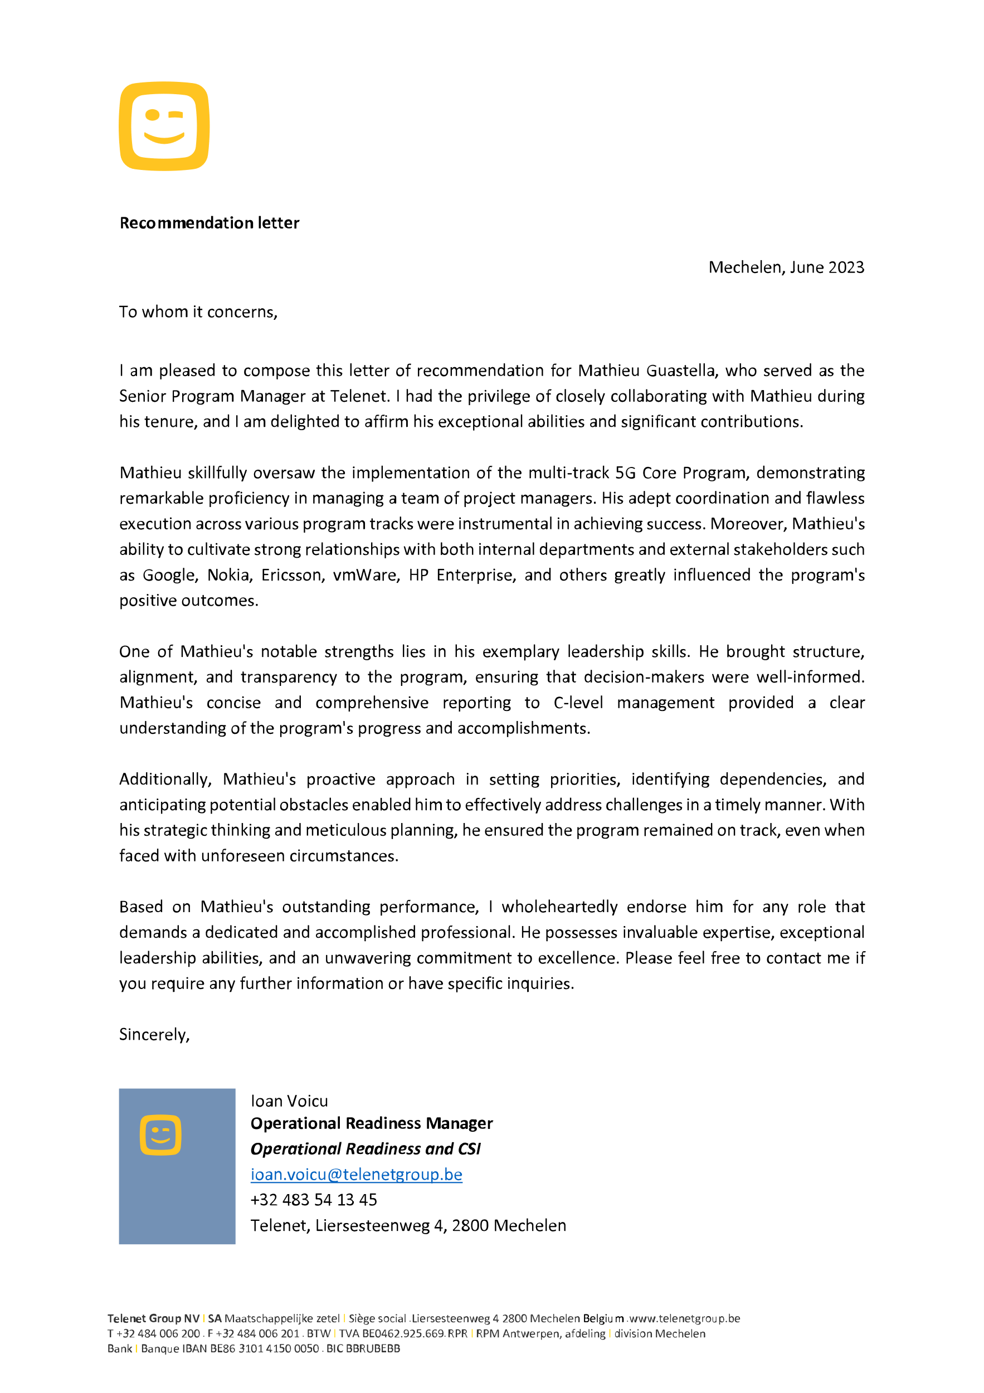

**Barco** — March 2022

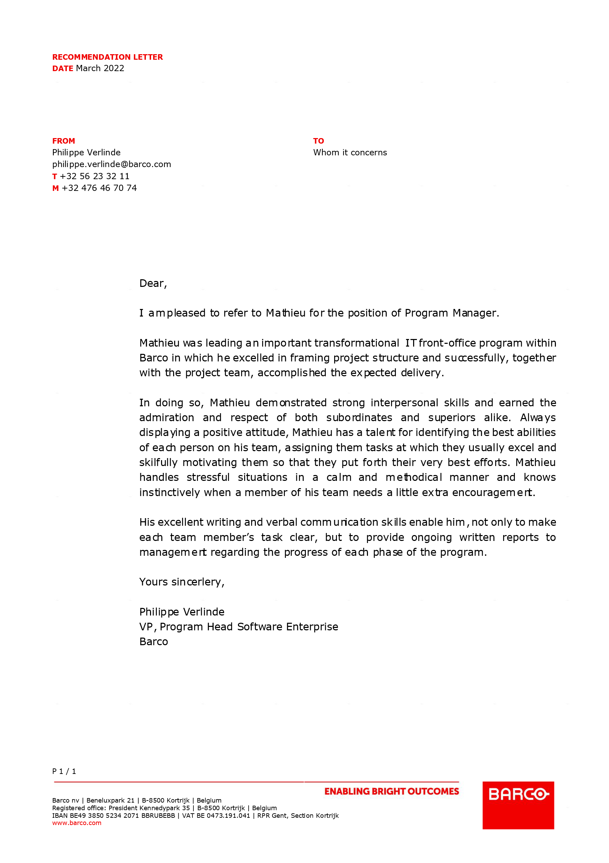

**BICS** — April 2021

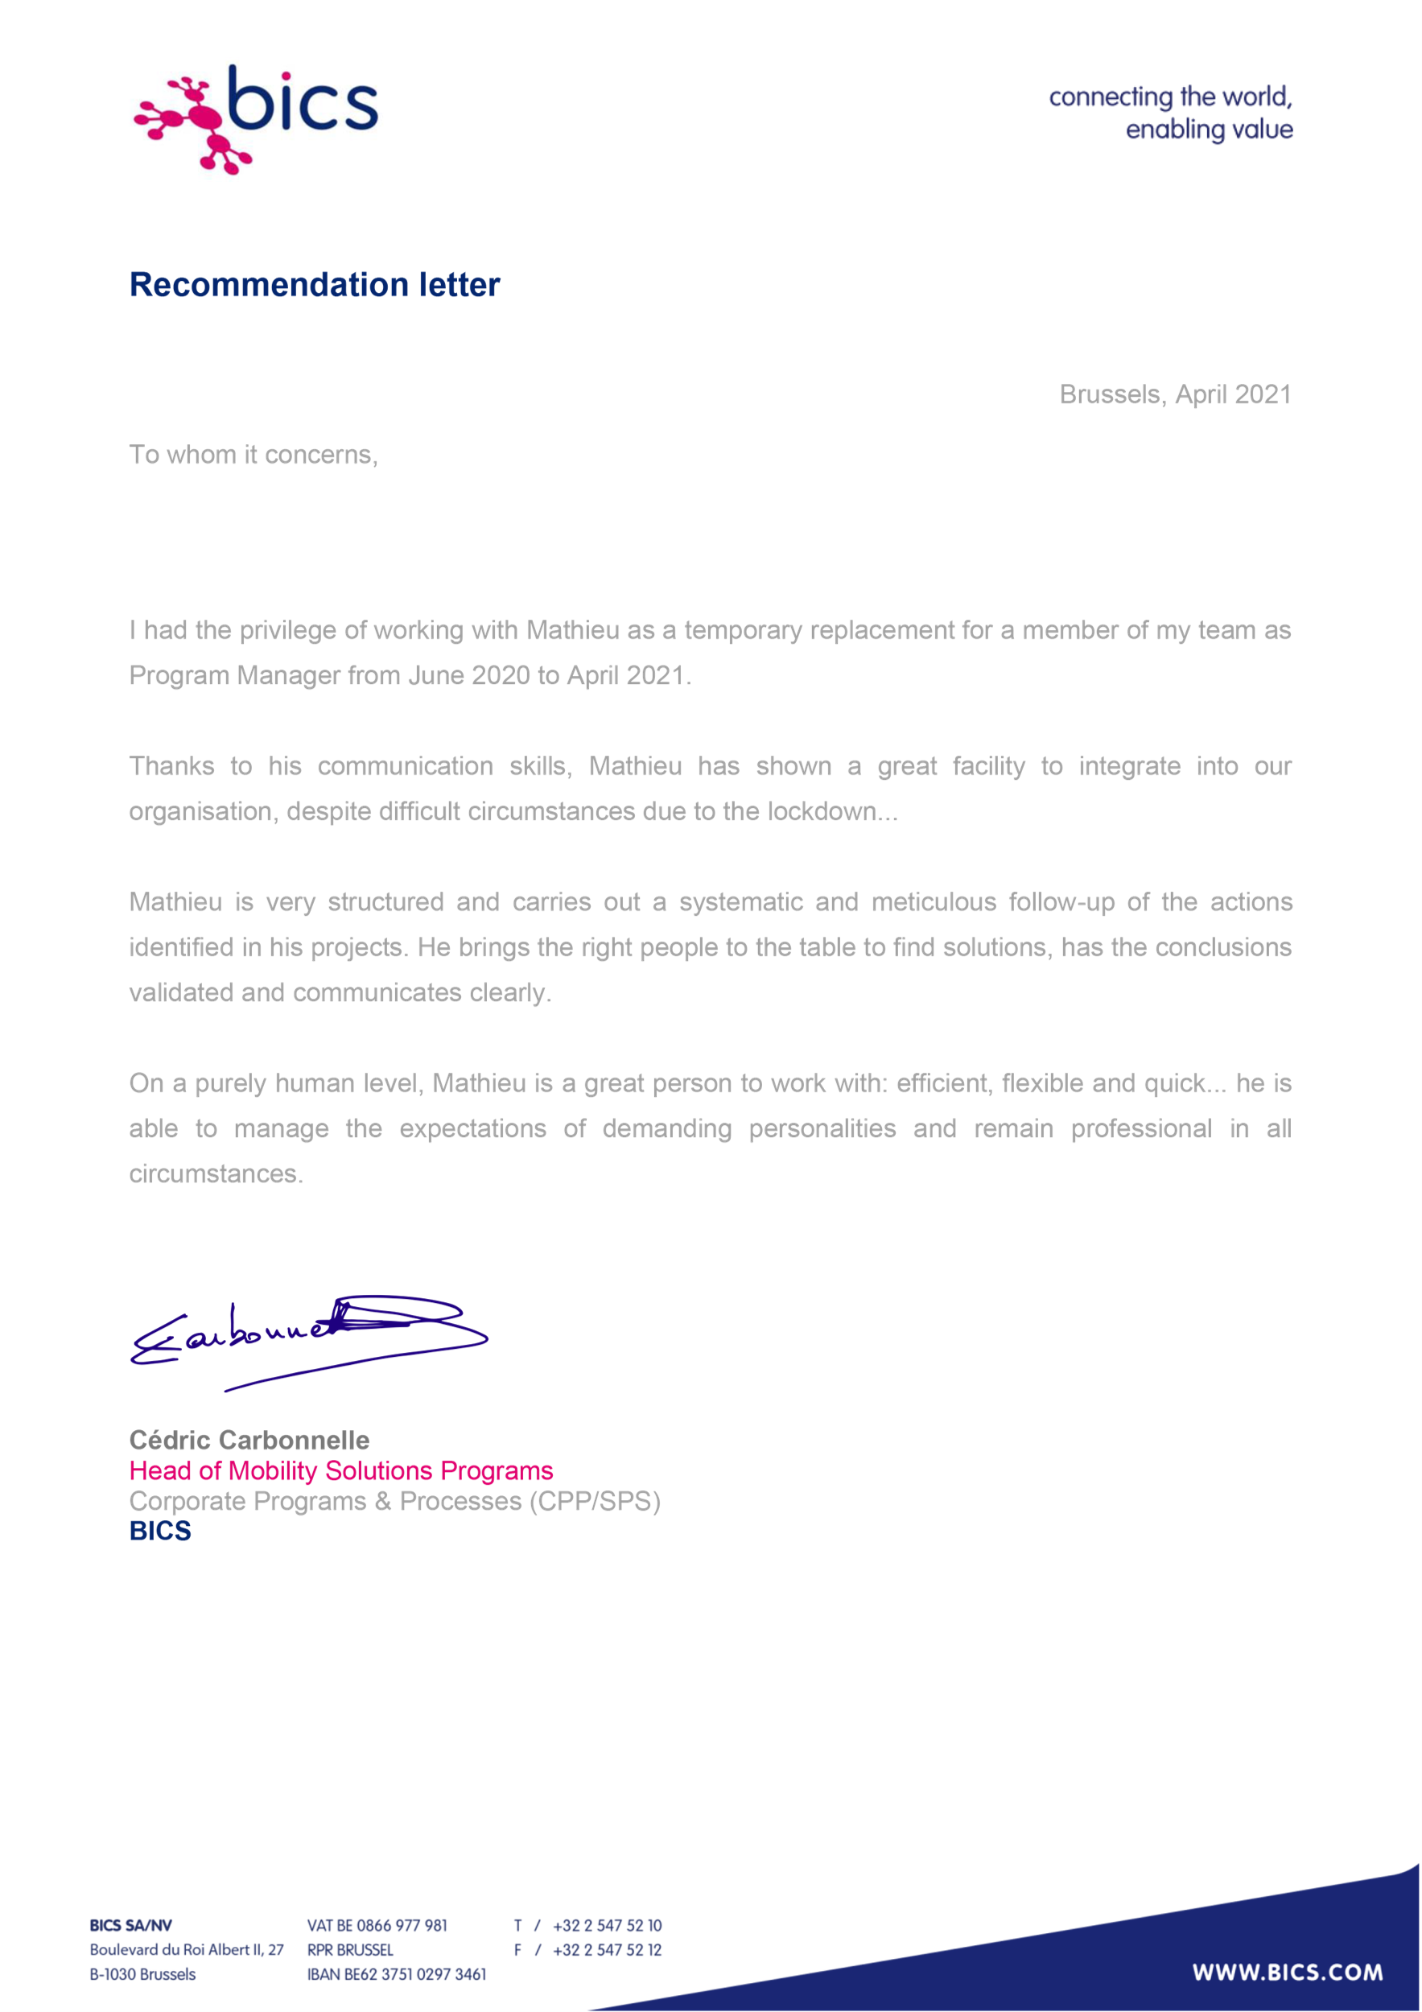

**Proximus** — January 2019

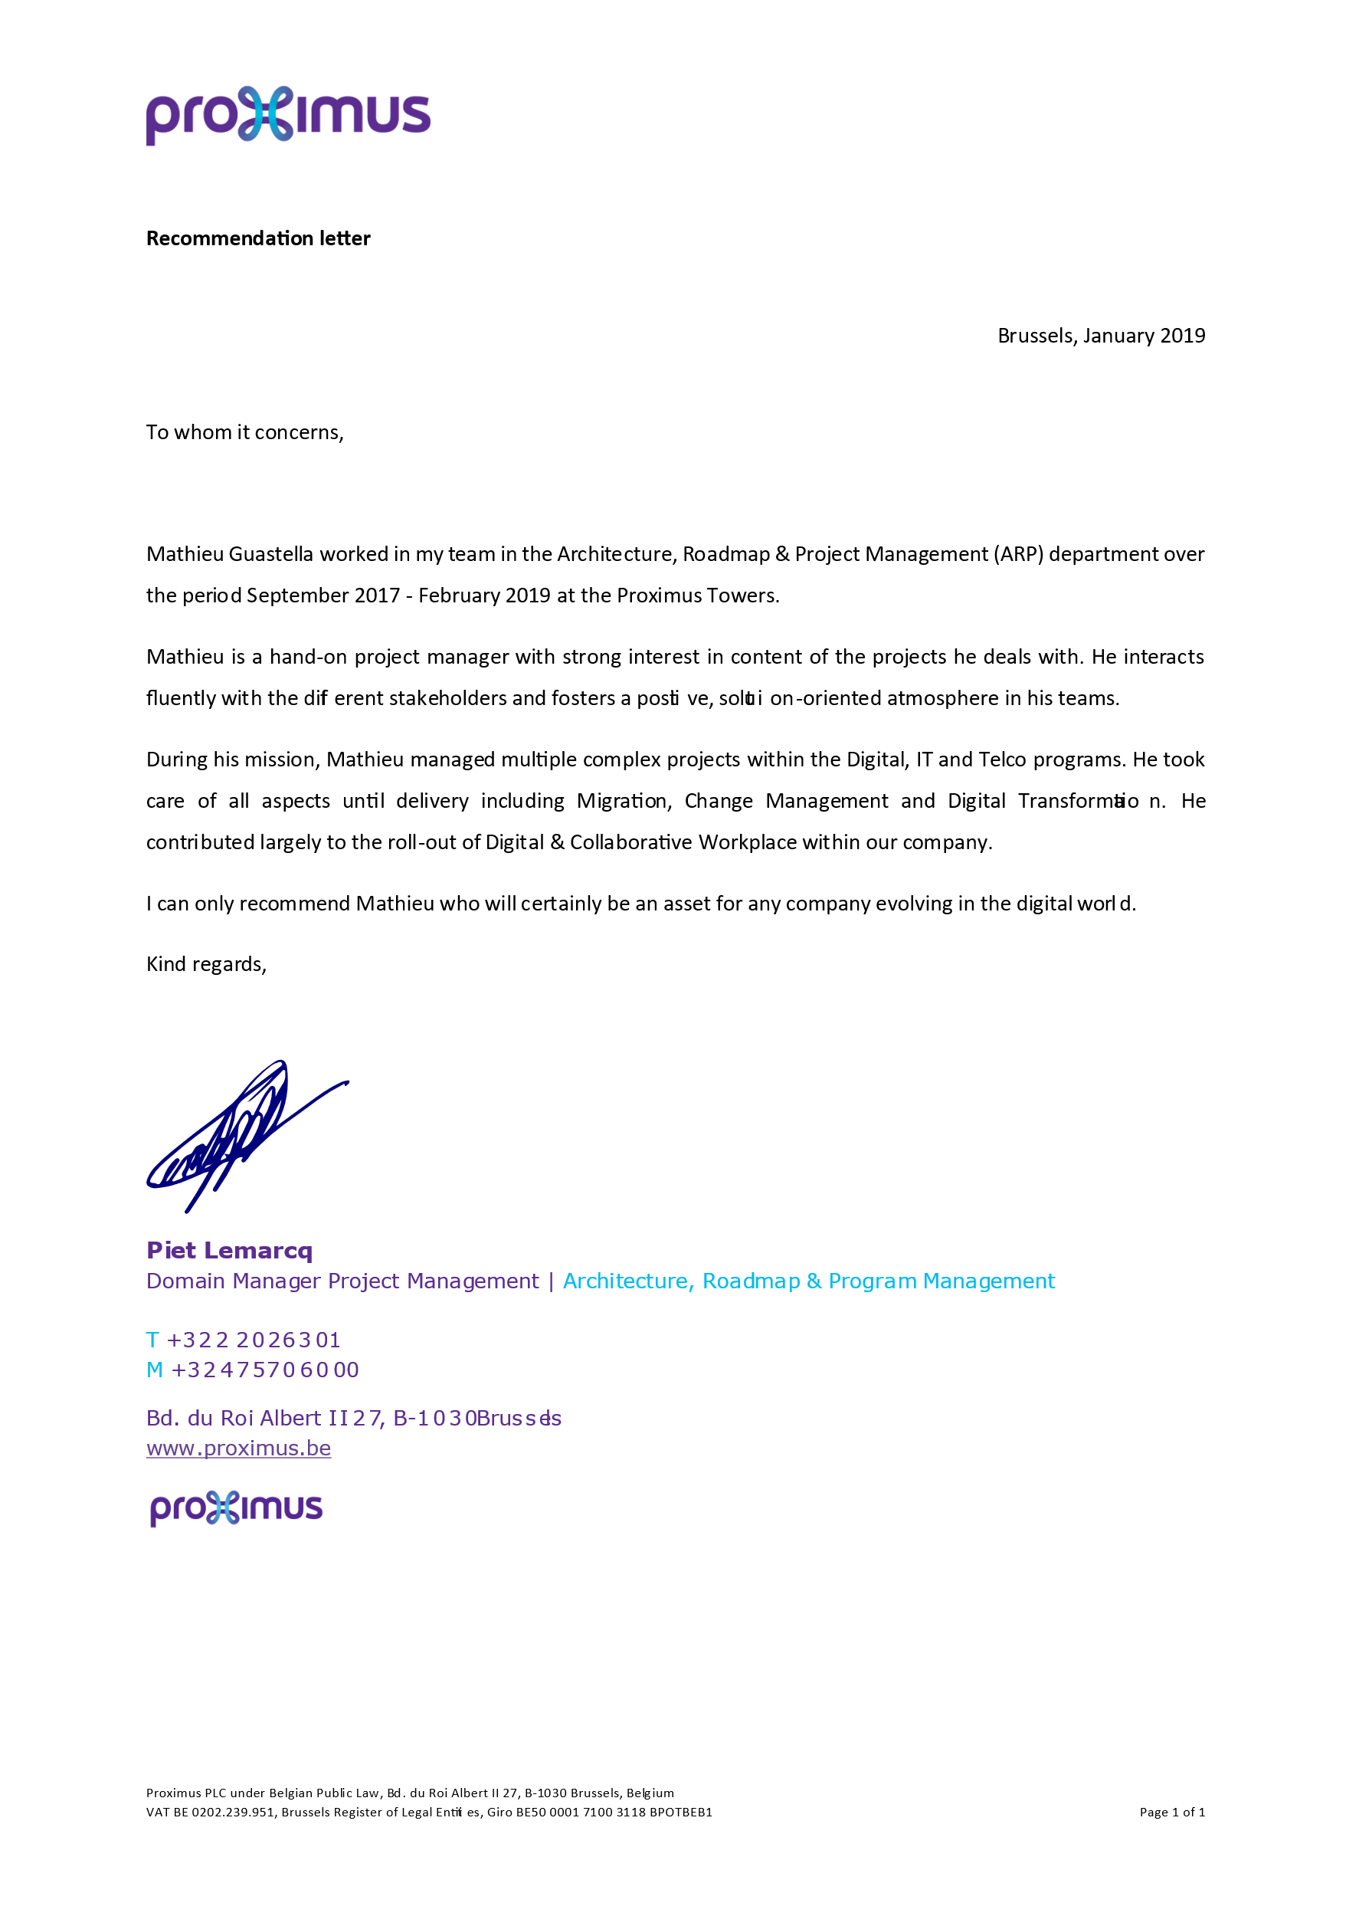

**Council of Bars and Law Societies of Europe** (CCBE) — January 2019

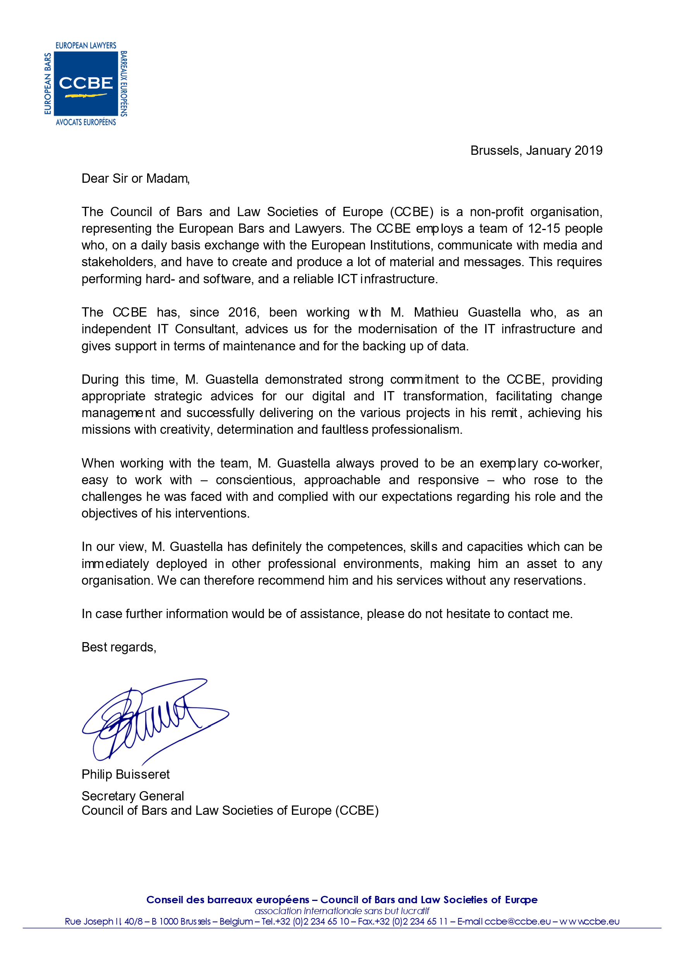

**Toyota Motor Europe** (TME) — August 2017

